**Introduction to Databases Assignment**

**Table of Contents:**

Part 1 – Retrieving Data using SQL Page 1 - 14

Part 1 A Page 1 - 4

Part 1 B Page 4 - 9

Part 1 C Page 9 - 14

Part 2 – Database Design, Implementation and Integrity Page 22 -

Part 2 A Page 14 - 22

Part 2 B Page 23

Part 2 C Page

**Part 1 – Retrieving Data using SQL**

**Part 1 A**

**SQL Code:**

SELECT shopper_first_name, shopper_surname, shopper_email_address, STRFTIME('%d-%m-%Y',date_joined)AS 'Date Joined', ROUND((JULIANDAY(DATETIME('2020-01-01')) - JULIANDAY(date_of_birth)) / 365 -0.5) AS 'Age (in years)'

FROM shoppers

WHERE date_joined >= '2020-01-01'

OR date_of_birth > '1990-01-01'

ORDER BY ROUND((JULIANDAY(DATETIME('2020-01-01')) - JULIANDAY(date_of_birth)) / 365)-0.5 DESC, shopper_surname;

**Explanation of the code:**

The first block of code (the SELECT statement and FROM clause) tells SQLite what to grab (SELECT) from my table. For example, SELECT shopper_email_address would select the shopper_email_address form the table. The line of code “ STRFTIME(‘%d-%m’-%Y, date_joined) AS ‘Date Joined’, is telling SQLite to display the date_joined column data in the format ‘ DD-MM-YYYY’ instead of SQLite’s default option which is to display dates like ‘YYYY-MM-DD’. The “AS ‘Date Joined’ ” part of the code tells SQLite to display the column name as Date Joined rather than “ STRFTIME(‘%d-%m’-%Y, date_joined) ” so that it is easier for users to understand and read it. ROUND((JULIANDAY(DATETIME('2020-01-01')) - JULIANDAY(date_of_birth)) / 365 -0.5) works out how old the shoppers are, and the “ROUND” function at the begging rounds the value to the nearest whole number. The FROM clause tells SQLite to get the data from the shoppers table, for example when I say SELECT shopper_first_name the FROM clause tells SQLite to get that from the shoppers table.

The second block of code (the WHERE and ORDER clause) tells SQLite to only display shoppers who joined in or after the 1st of Jan 2020 or those aged less than 30 on the 1st of Jan 2020. And they tell SQLite to ORDER the results by the “Age (in years)” column in Descending order, and then by shopper_surname.

**Screenshot of the query result:**

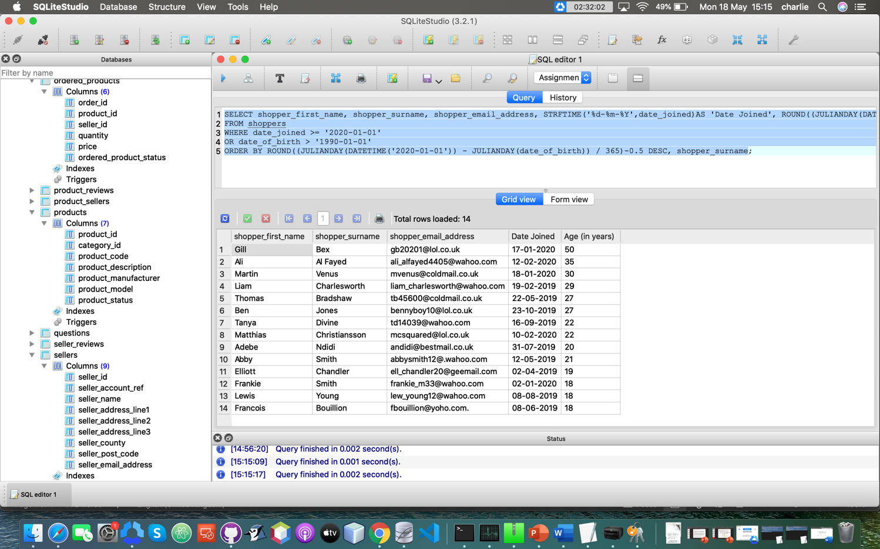

**Testing:**

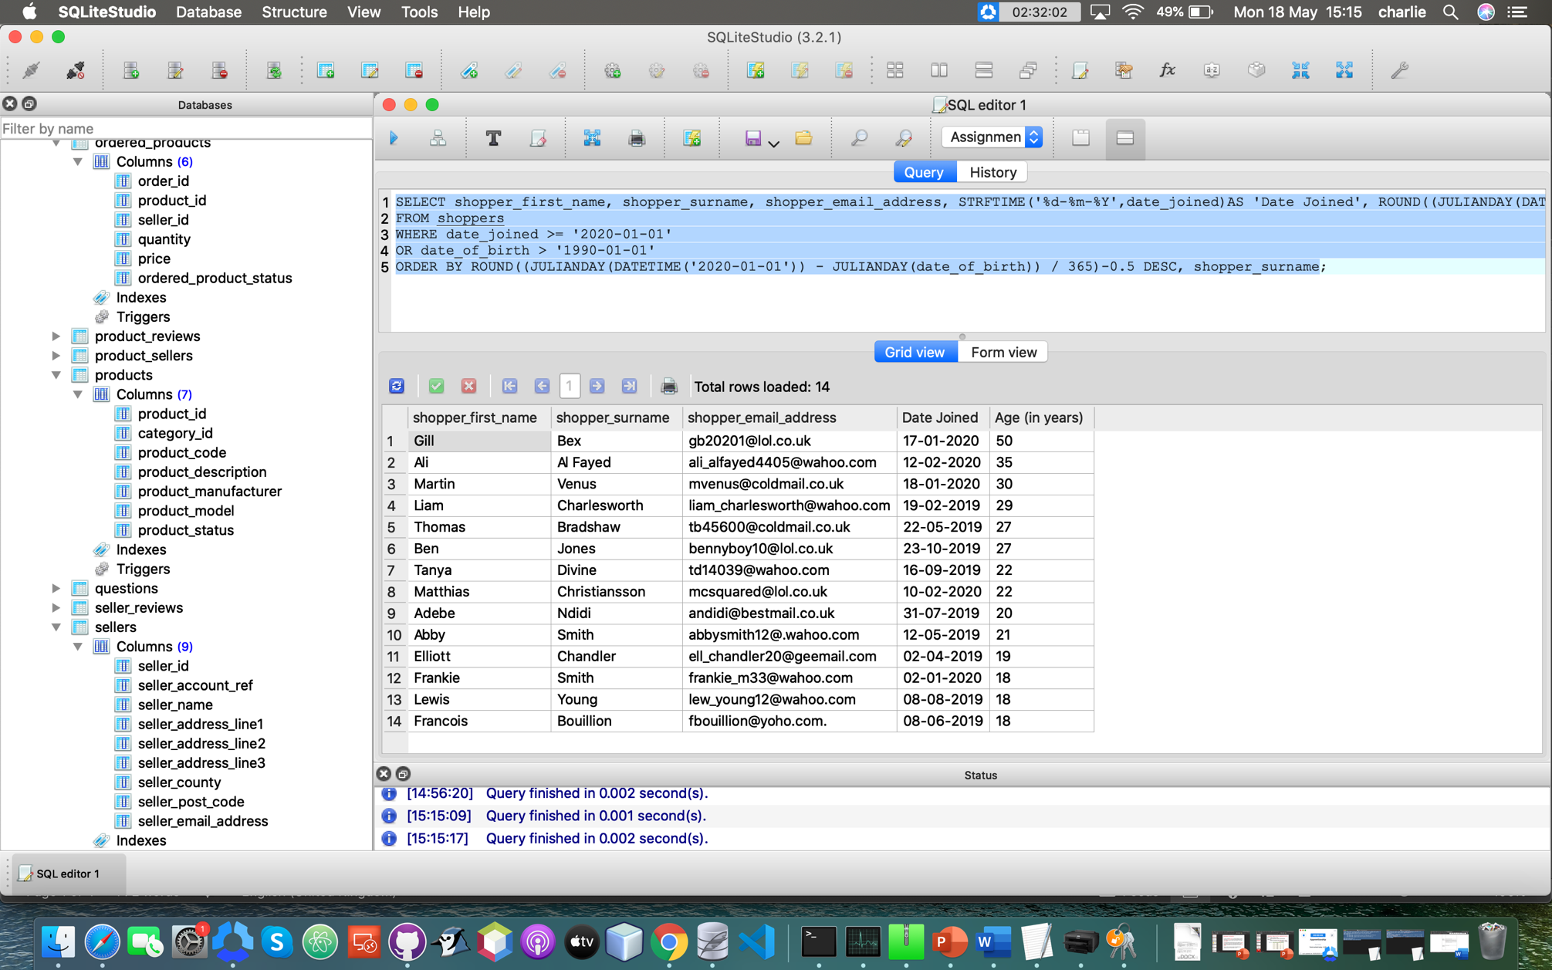

Here you can see that only shoppers who joined on or after the 1st of Jan 2020 OR shoppers who are less than 30 years old on 1st of Jan 2020 are shown, I have done this in order to meet the clients requirements.



As you can see here the “Date Joined” column is displayed in the format “DD-MM-YYY” as opposed to the default SQLite format “YYYY-MM-DD”, therefore meeting the clients requirements.



And finally, you can see in the screenshot above that these results are ordered by the age and the highest is first, this is proved by 50 being at the top and the ages descending after that. After age the results are then ordered by shopper_surname (alphabetically), this is shown by Frankie Smith being above Lewis Young despite them both being the same age, which once again meets the client requirements.

**Part 1 B**

**SQL Code:**

SELECT s.shopper_id, s.shopper_first_name, s.shopper_surname, s.shopper_account_ref, op.order_id, op.ordered_product_status, op.quantity, '£' || ROUND(op.price,2) AS 'price', se.seller_name, pr.product_description, STRFTIME('%d-%m-%Y', so.order_date) AS 'Order Date'

FROM shoppers s

INNER JOIN ordered_products op ON op.order_id = so.order_id

INNER JOIN sellers se ON op.seller_id = se.seller_id

INNER JOIN products pr ON op.product_id = pr.product_id

INNER JOIN shopper_orders so ON op.order_id = so.order_id

AND s.shopper_id = so.shopper_id

WHERE s.shopper_account_ref = @id

ORDER BY so.order_date DESC;

**Explanation of the code:**

The first block of code (the SELECT statement and FROM clause) tells SQLite what to grab (SELECT) from my tables. For example, SELECT op.quantity would select the quantity column form the ordered_products table, as I have assigned a table alias of ‘op’ to ordered_products. The “ ’£’ || ROUND(op.price, 2)” part of the code tells SQLite to display the op.price column data with a pound sign (£) at the beginning and to round the op.price data to two decimal points. The “ AS ‘Price’ ” part of the code tells SQLite to display the column name as “Price” rather than op.price, this is to make the column names easier to read for the users. The

“ STRFTIME(‘%d-%m-%Y’, so.order_date) AS ‘Order Date’ ” part of the code tells SQLite to display the so.order_date column as DD – MM – YYYY rather than the SQL default of YYYY – MM – DD. And to display that column name as ‘Order Date’ rather than ‘STRFTIME('%d-%m-%Y', so.order_date)‘, so that the users can read the column name easier and understand what the column is showing easier. The FROM clause tells SQLite that I want to get the data from the shoppers table, it is also where I assign the table alias of s to shoppers.

The second block of code (the INNER JOINS) tells SQLite what join to use and how to join the tables to each other so that I can SELECT data from multiple tables, like op.price from the ordered_products table and pr.product_description from the products table. This is also where I assign the rest of the tables table aliases, like se for sellers and pr for products.

The last block of code (the WHERE clause and ORDER BY clause) tells SQLite to only show values where the s.shopper_account_ref is the same as what the user has inputted. The ORDER BY clause tells SQLite how to order the results, for this code it tells SQLite to order the results by displaying the most recent order_date first (or displaying so.order_date on descending order (DESC)).

**Screenshots of the query results and user input (if any):**

First instance of user input:

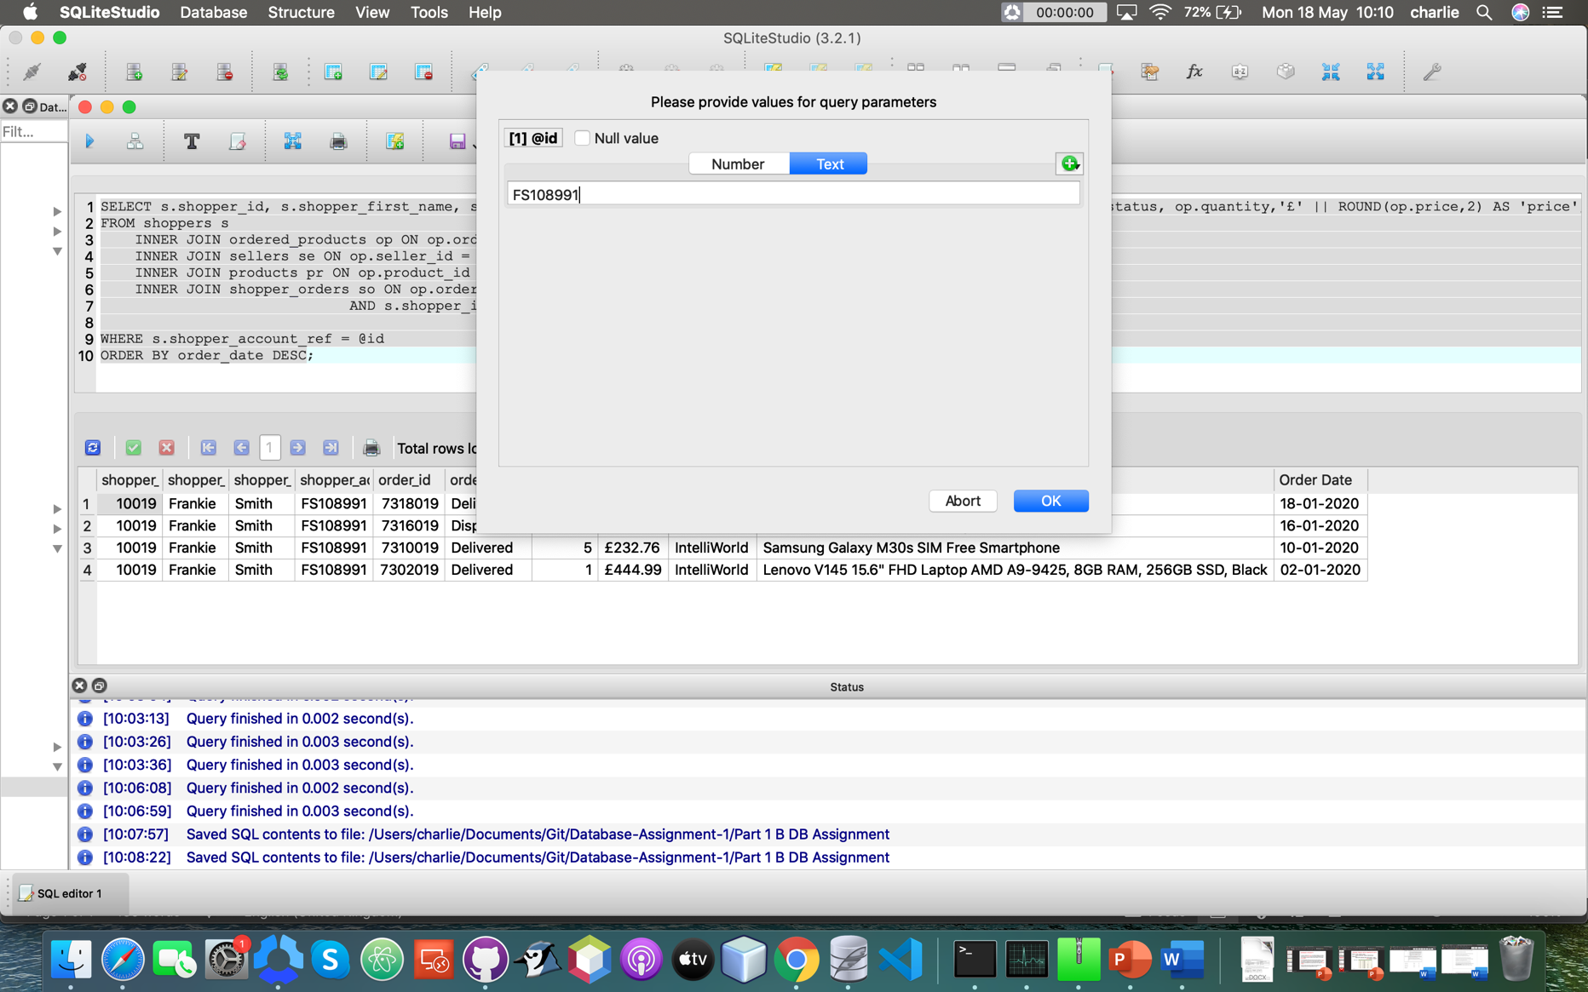

First query results:

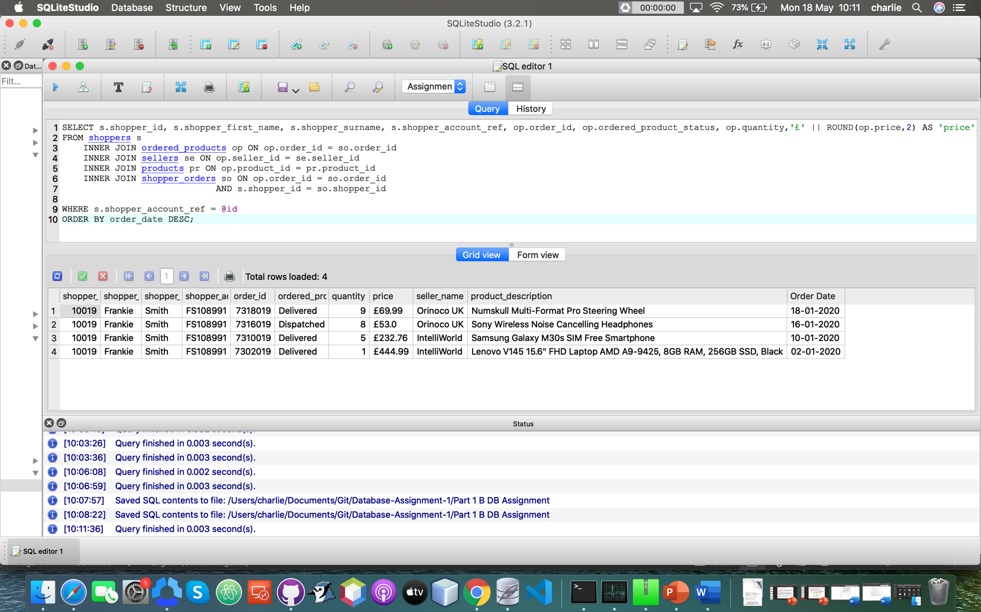

Second instance of user input:

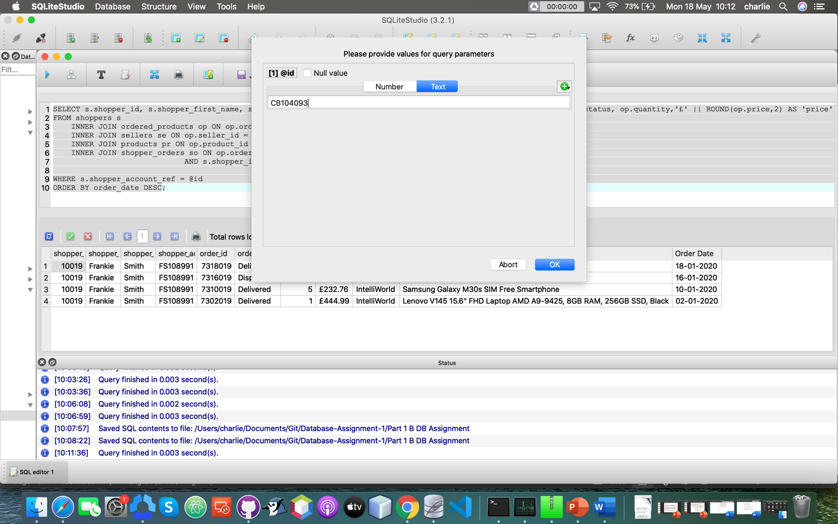

Second query results:

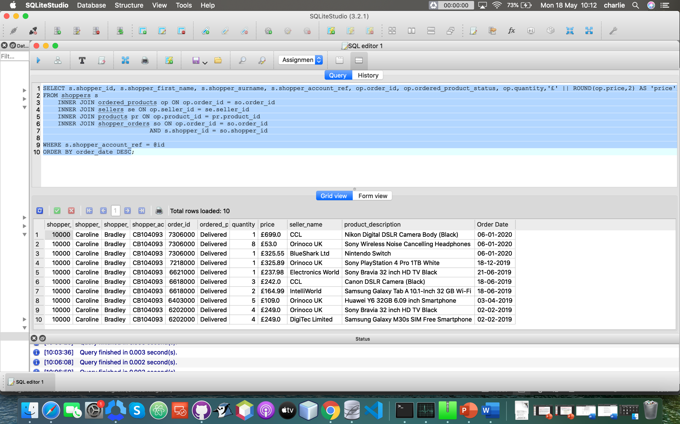

**Testing:**

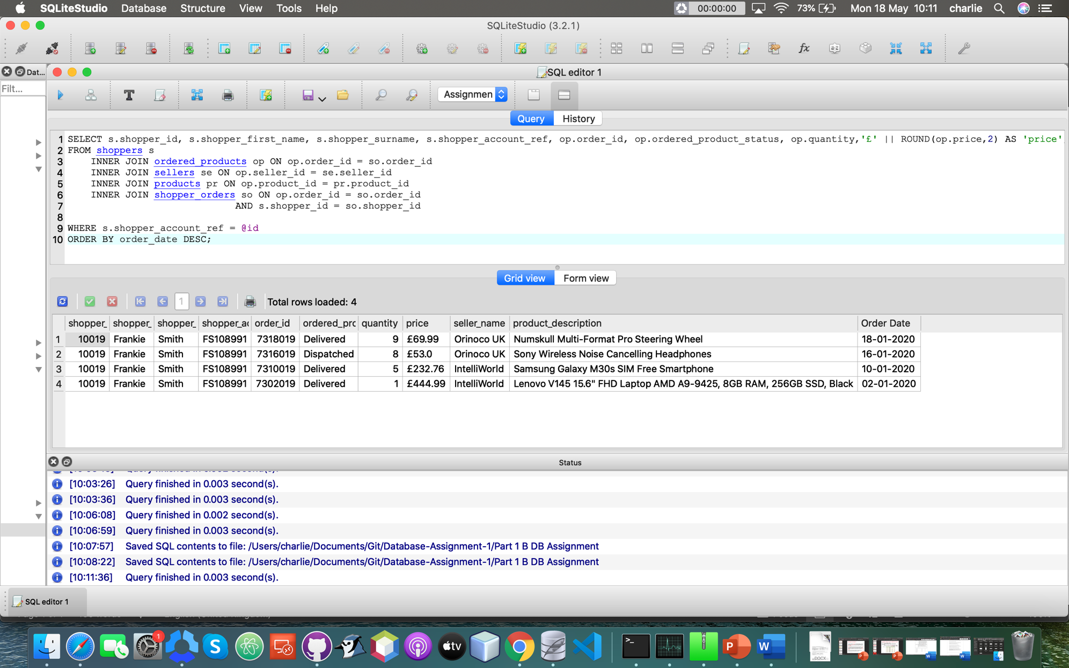

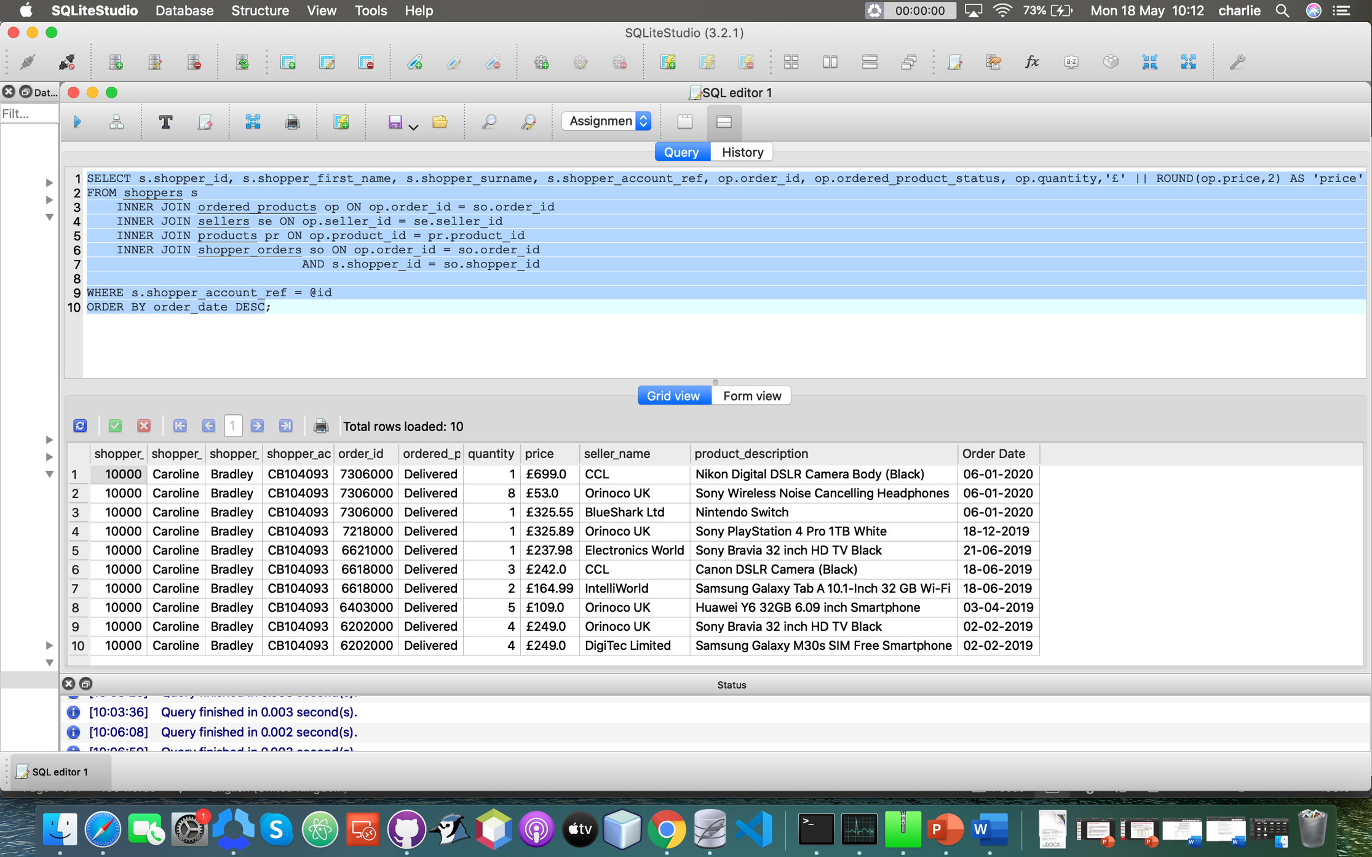

In these two query results you can see the “Order Date” column is displayed in the format ‘DD-MM-YYYY’ instead of SQLite’s default format of “YYYY-MM-DD”, I have done this in order to meet the client requirements.

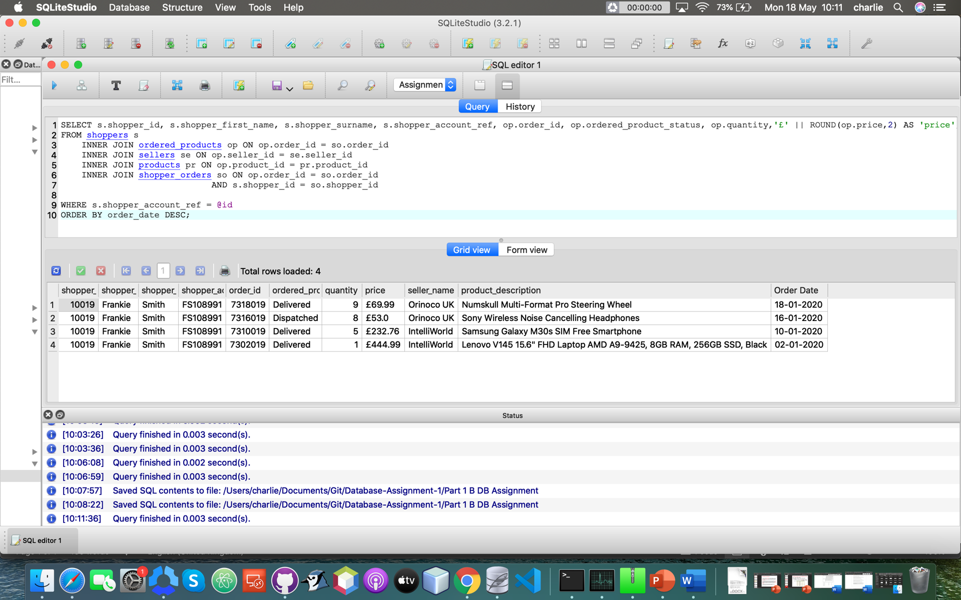



Here you can see that the results are ordered by the “Order Date” column, showing the most recent order first (descending), meeting the client requirements.

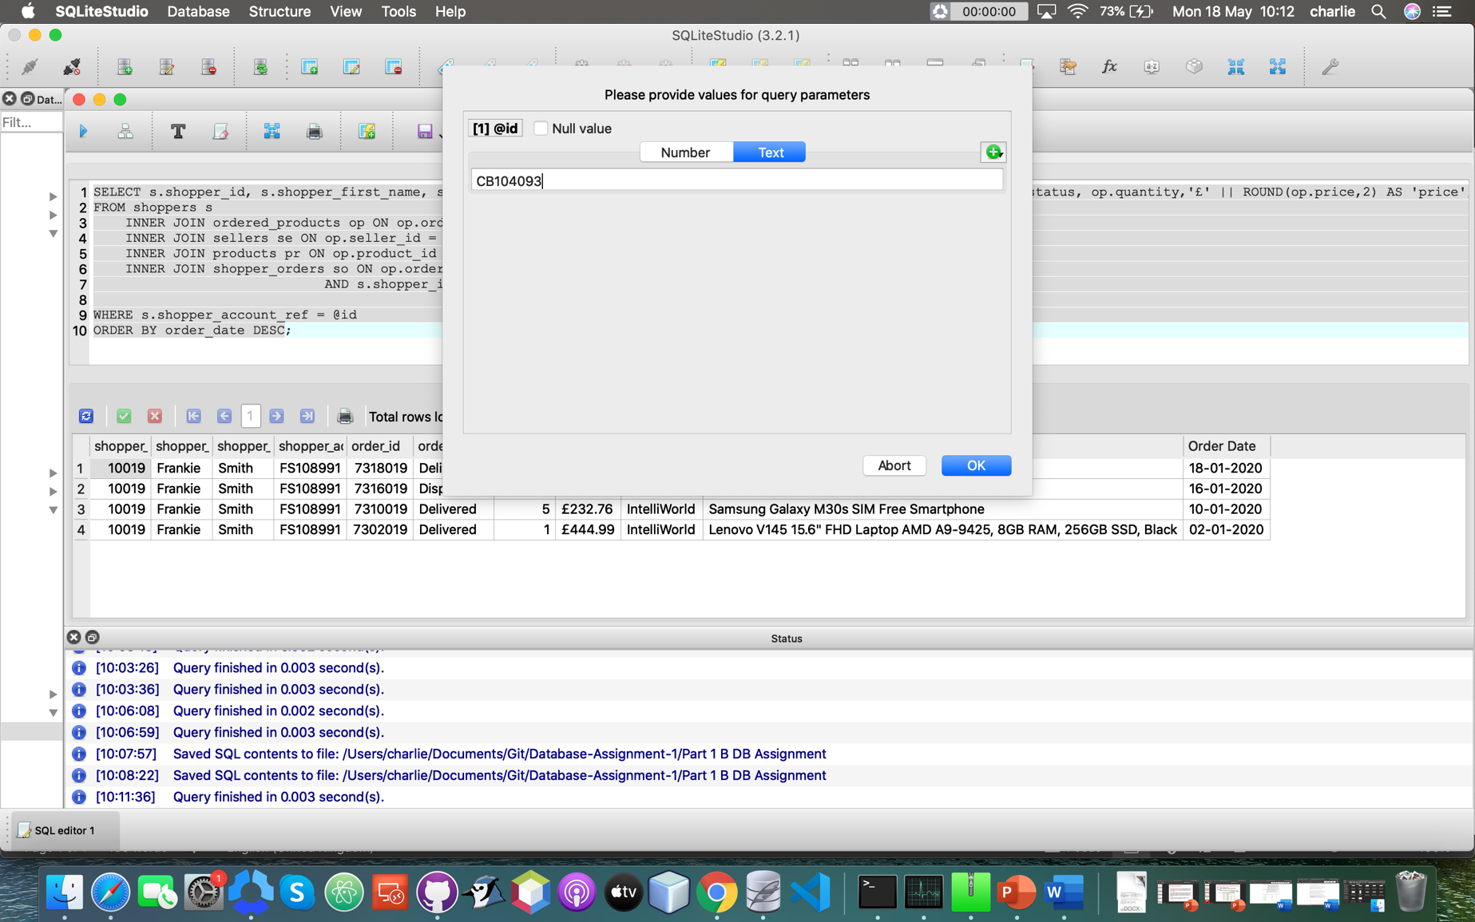

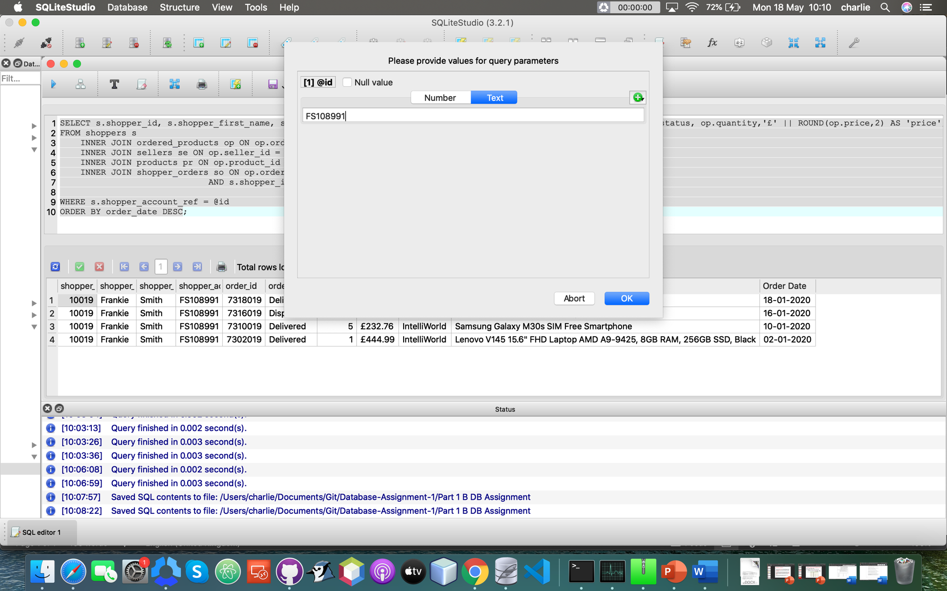

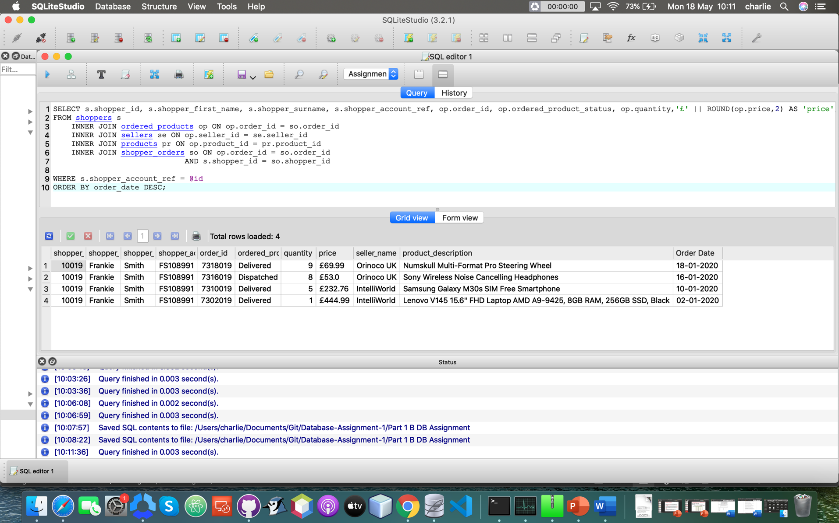

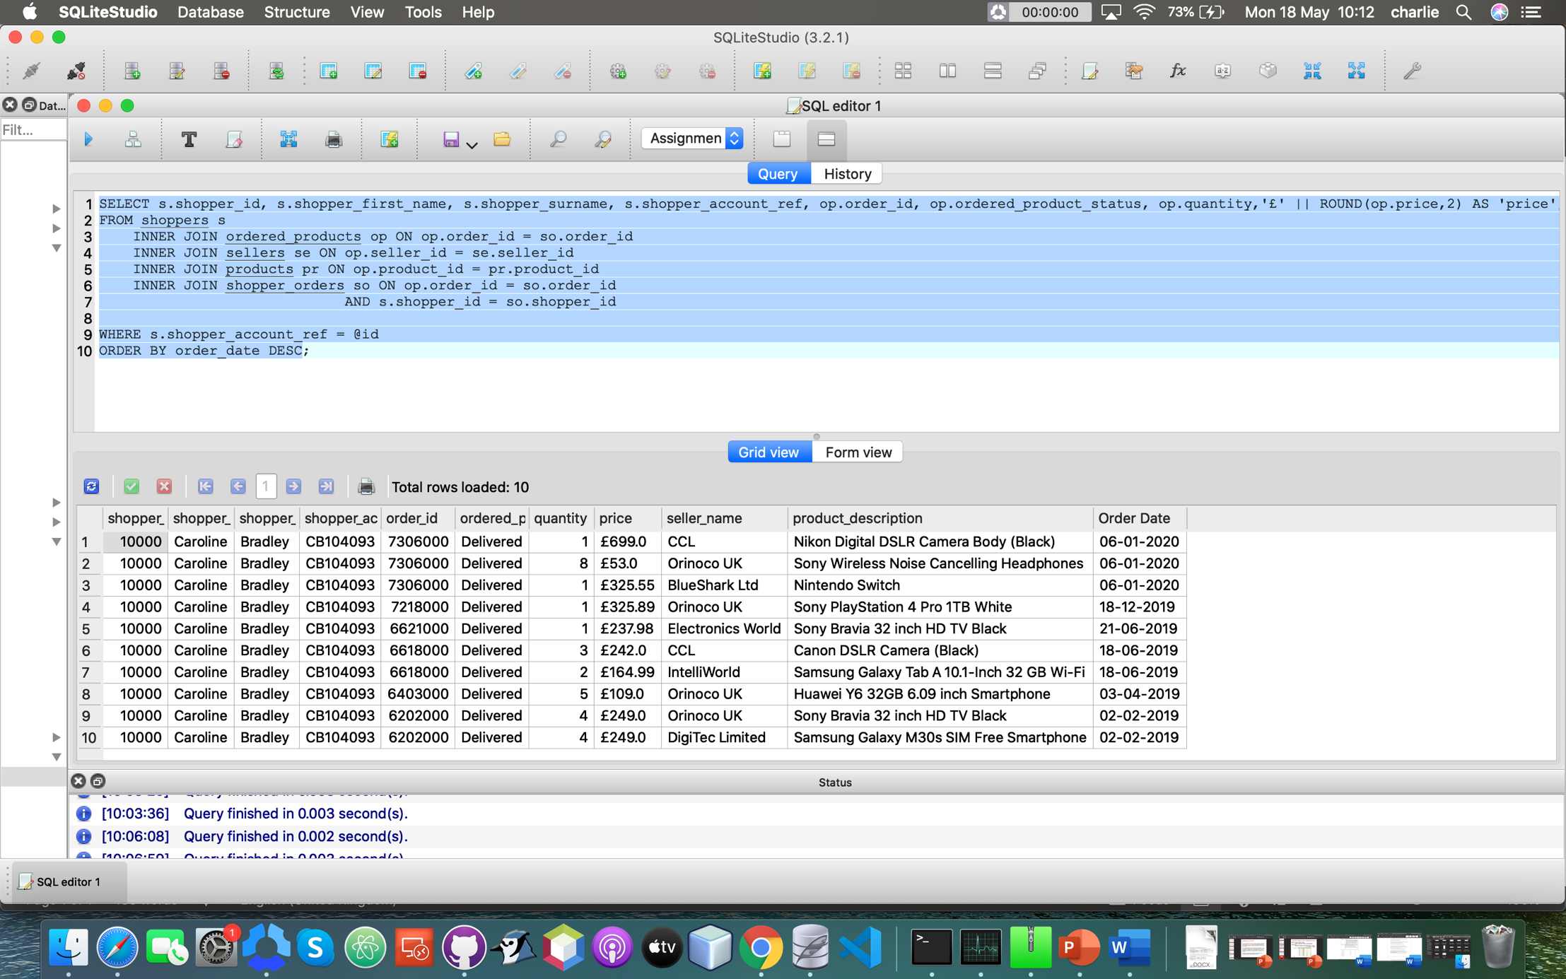

Here you can see two examples of the program prompting the user to enter a shopper’s account ref in order to display the shopper_ids 10019 & 10000, once again fulfilling the client requirements.

**Part 1 C**

**SQL Code:**

SELECT IFNULL(seller_account_ref, 'N/A') AS 'Seller Account Ref', IFNULL(seller_name, 'N/A') AS 'Seller Name', pr.product_code, pr.product_description, COUNT(op.order_id) AS 'Number of Orders', IFNULL(SUM(quantity),0) AS 'Total Quantity Sold', '£' || IFNULL(ROUND(SUM(op.quantity *op.price),2),0) AS 'Total Value of Sales', order_date

FROM products pr

LEFT OUTER JOIN ordered_products op on pr.product_id = op.product_id

LEFT OUTER JOIN sellers se on op.seller_id = se.seller_id

LEFT OUTER JOIN shopper_orders so on op.order_id = so.order_id

WHERE order_date IS NULL OR

order_date > '2019-06-01'

GROUP BY seller_name, product_description;

**Explanation of the code:**

The first block of code (the SELECT statement and FROM clause) tells SQLite what to SELECT from the tables, for example SELECT pr.product_code is telling SQLite to grab the product_code data from the products table, as I have assigned the table alias of pr to products. The first piece of code “ IFNULL(seller_account_ref, ‘N/A’) AS ‘Seller Account Ref’, tells SQLite that if the value for seller_account_ref is NULL (IFNULL) then display it as ‘N/A’. It also tells SQLite to display that column name as “Seller Account Ref”. The next piece of code does the same except for the seller_name column and displays the column name as “Seller Name”.

COUNT(op.order_id) AS ‘Number of Orders” is telling SQLite to count how many rows have order_id’s and to display the total, in my case it will display the total amount of order_id’s for each seller but I will explain that later, and to call that column “Number of Orders”. The next piece of code “ ‘£’ || IFNULL(ROUND(SUM(op.quantity*op.price),2),0) AS ‘Total Value of Sales’ tells to find the sum of op.quantity*op.price and round the answer to two decimal places. Also this piece of code tells SQLite to put a pound sign (£) in front of the data, and if the data is NULL then display it as zero ‘0’, and to display that column name as ‘Total Values of Sales’. The “FROM products pr” clause tells SQLite to get the data from the products table (unless told otherwise in the SELECT statement), and this where the table alias pr is assigned to products.

The next block of code (the LEFT OUTER JOIN statements) tell SQLite how to join the different tables together and it is also where I assign the rest of the tables table aliases. For example shopper_orders so and sellers se and so on.

The last block of code (the WHERE and GROUP BY clauses) tells SQLite to display the data where the order_date column is NULL or greater than the 1st of June 2019. The “ GROUP BY seller_name, product_description; ” part of the code tells SQLite to group the data by seller_name, and then product_description.

**Screenshots of the query results:**

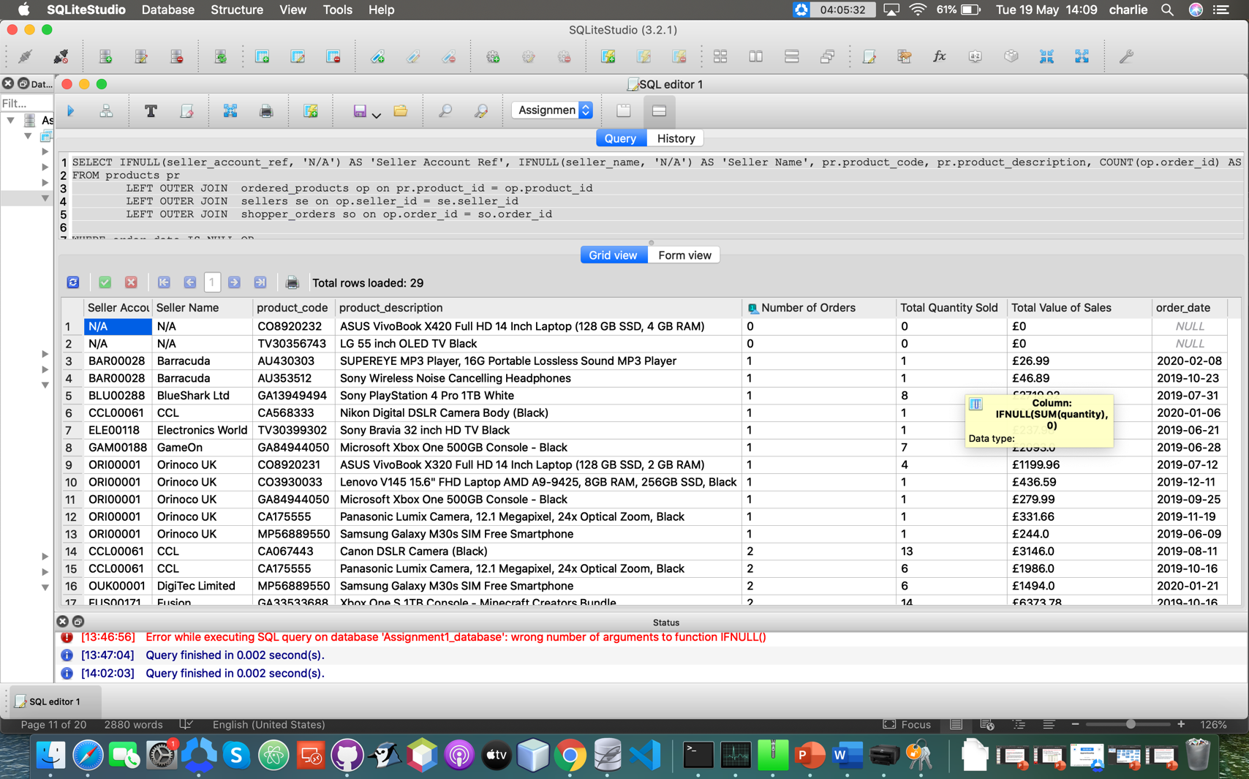

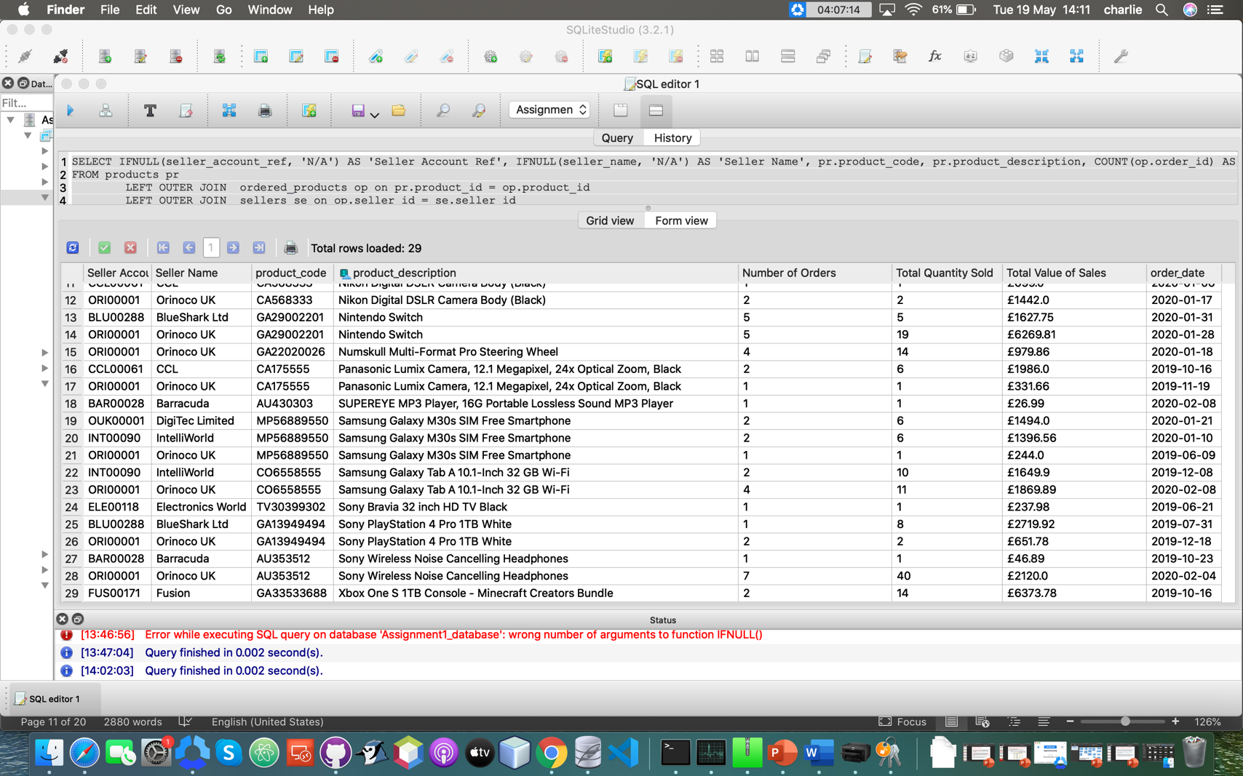

**Testing:**

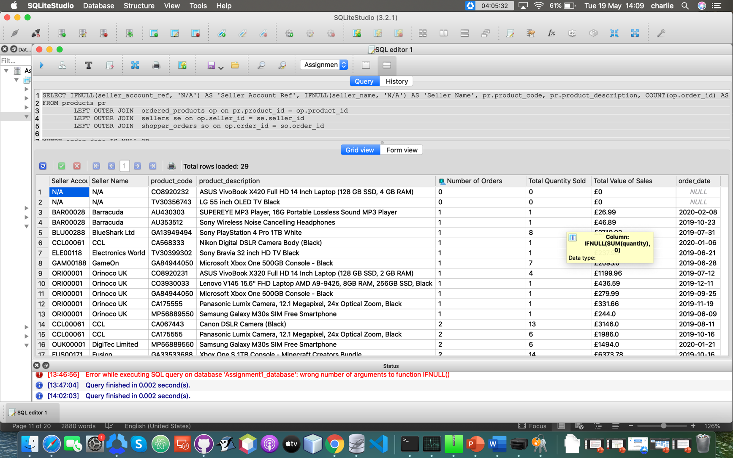



Here you can see that the “Total Value of Sales” column is right justified with two decimal places and prefixed by a pound sign (£), this is done in order to meet the client requirements.

**Fig 1:**

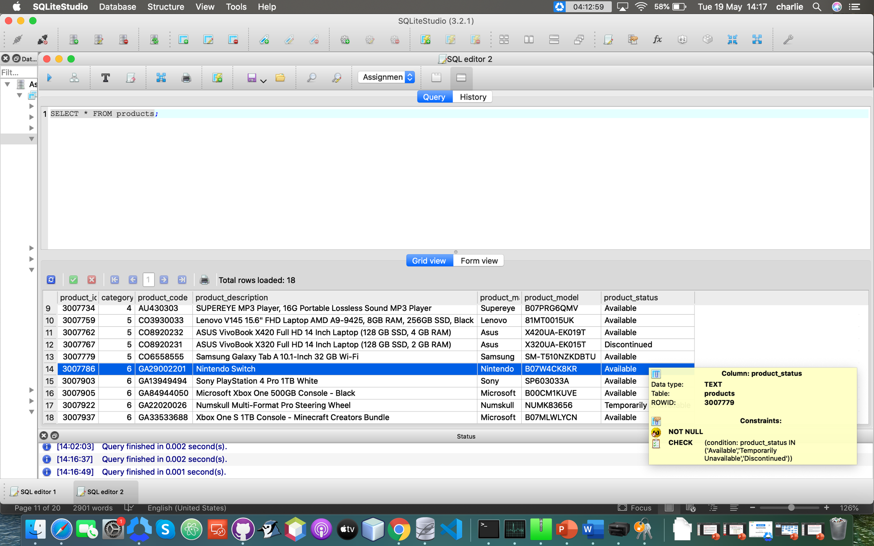

**Fig 2:**

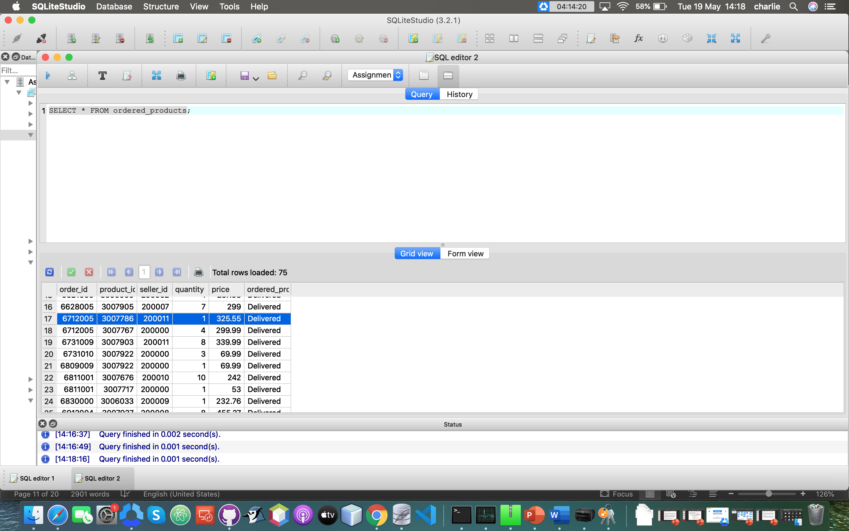

**Fig 3:**

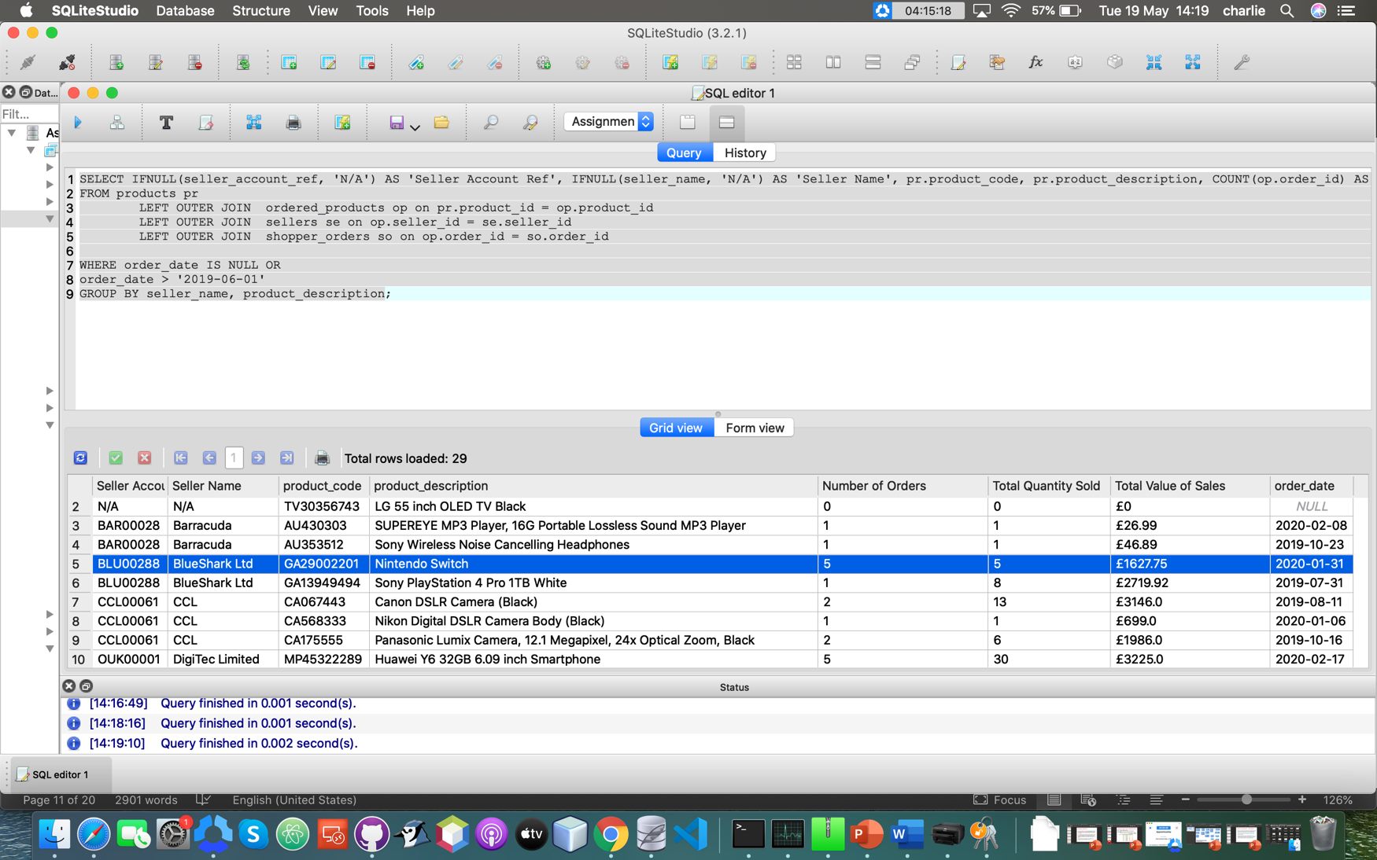

In these figures you can see that the “Total Value of Sales” column comes up with the correct values, as you can see the individual price of a single Nintendo Switch in Fig 2 (product_id 3007786 as shown in Fig 1) and you can see in Fig 3 how many have sold. Overall you can see that the Total Value of Sales column produces the expected result, and therefore meets the client requirements.





Here you can see that any NULL values for an INTEGER column has been displayed as zero ‘0’ not NULL, for example the two rows at the top have NULL values in the three INTEGER columns as there have been no orders for them, meeting the client requirements.

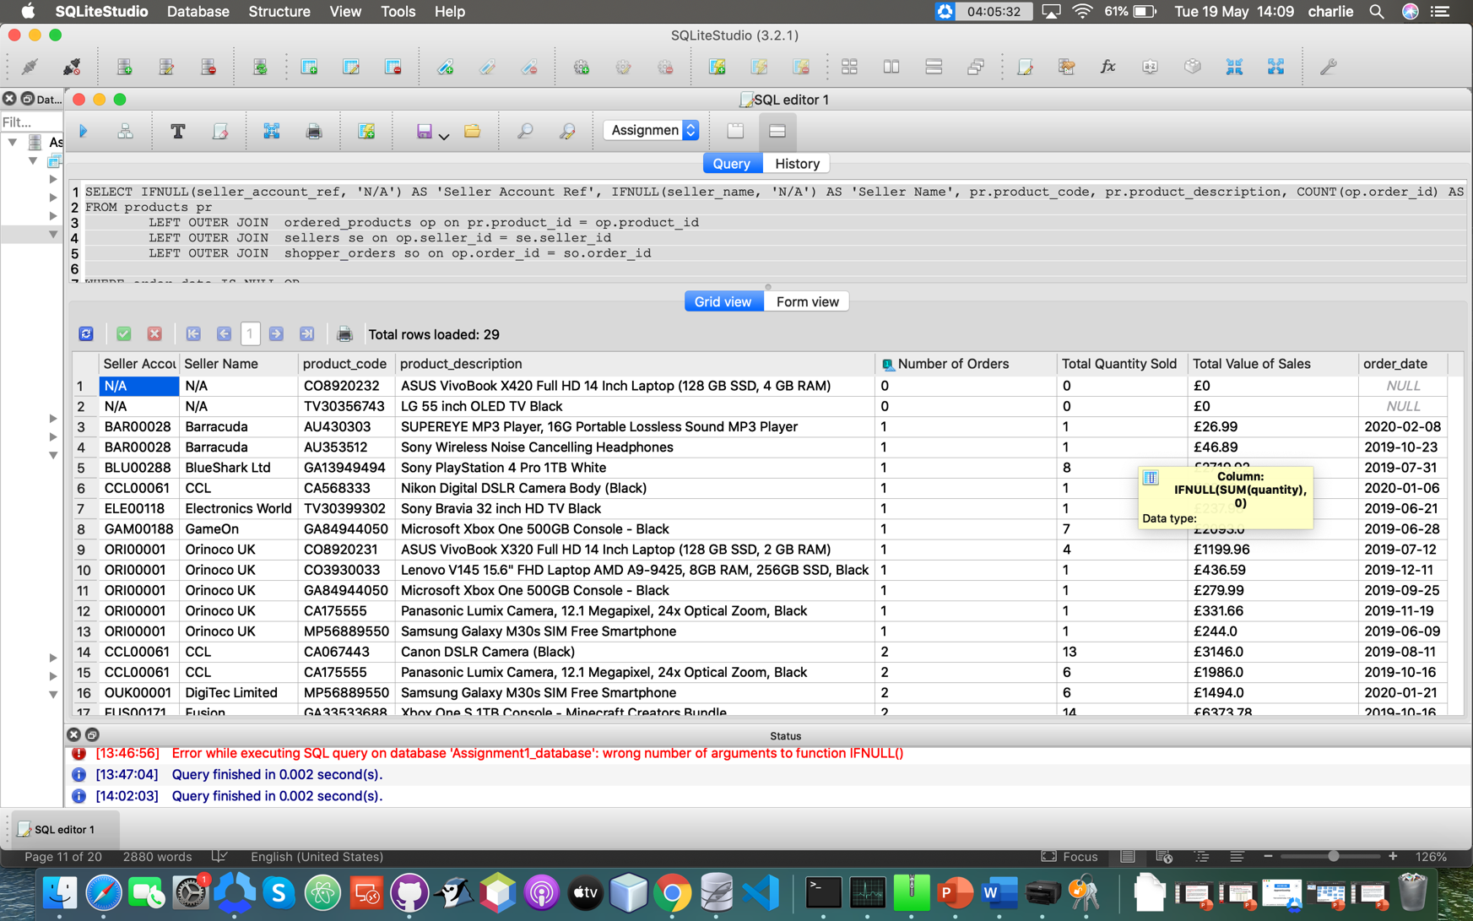

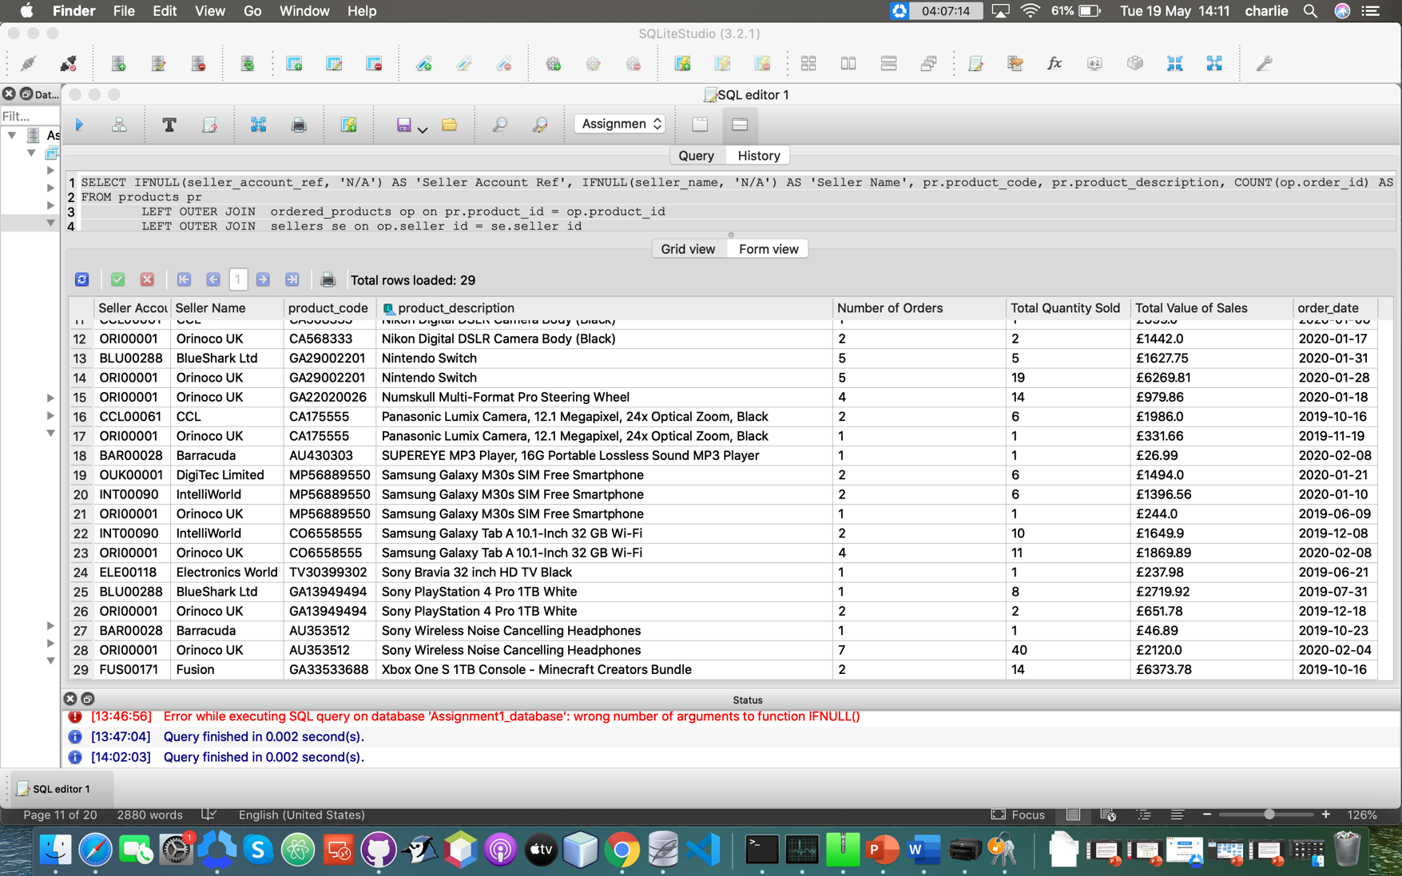

In the two above screenshots you can see that the top two rows that have no orders have their “Seller Account Ref” and “Seller Name” columns displayed as “N/A” instead of “NULL”, this is to make it simpler for the users to understand the column data.

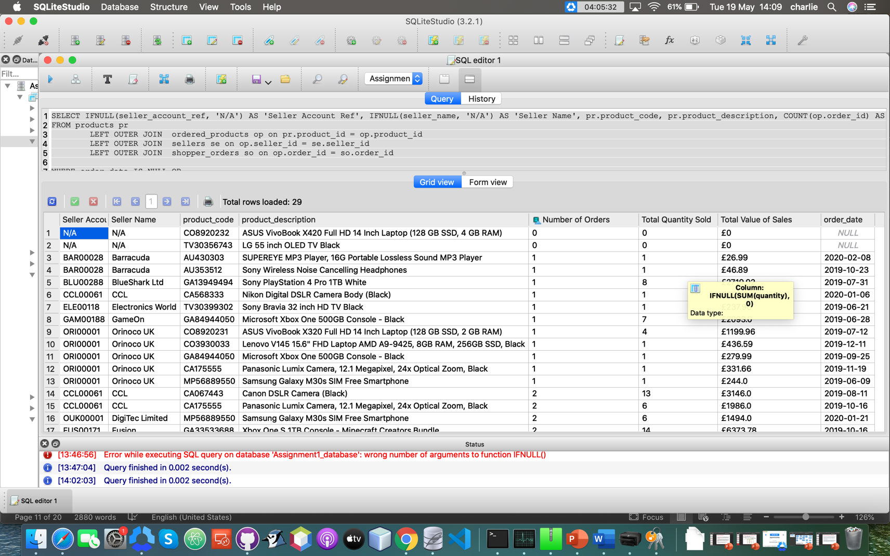

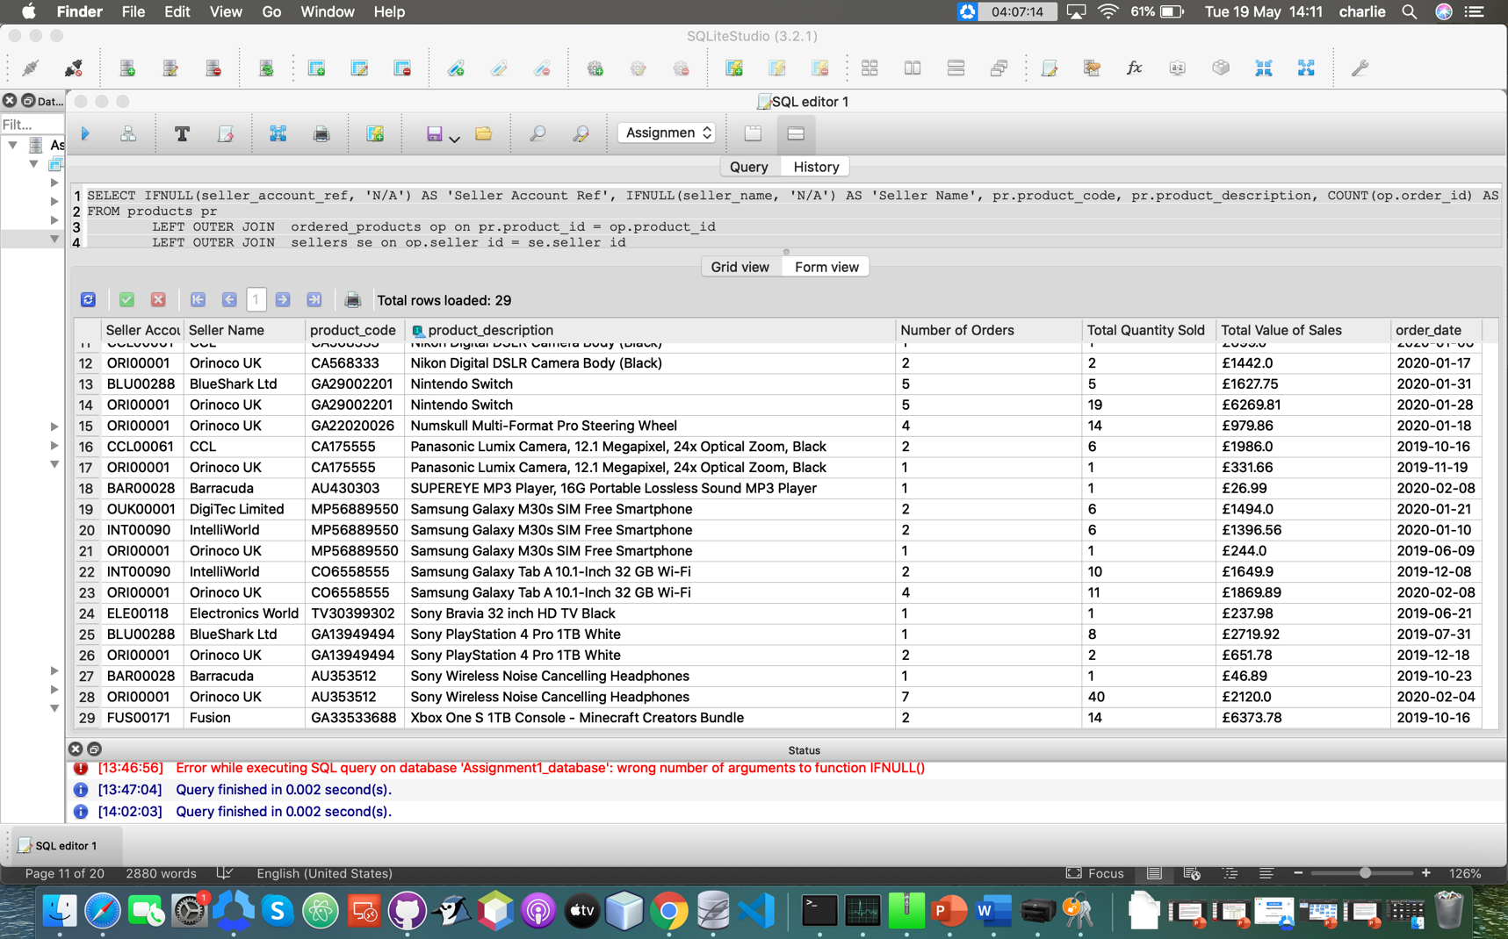

Finally, you can see here that the query results are grouped by seller_name and then by product_description, which once again meets the client requirements.

**Part 2 – Database Design, Implementation and Integrity**

**Part 2 A**

**Assignment 1 - Question 2A**

**Conceptual Design:**

**Seller review Entity:**

|  |  |  |  |
| --- | --- | --- | --- |
| **Seller review number** | **Reviews about the sellers** | **Seller star review**  **( * Poor, ** Fair, *** Good,**  **\*\*\*\* Very Good,**  **\*\*\*\*\* Excellent)** | **Date time feedback submitted** |
|  |  |  |  |
|  |  |  |  |
|  |  |  |  |

**Product review Entity:**

|  |  |  |  |
| --- | --- | --- | --- |
| **Product review number** | **Reviews about products** | **Product star review**  **(* Poor, ** Fair, *** Good,**  **\*\*\*\* Very Good,**  **\*\*\*\*\* Excellent)** | **Date time feedback submitted** |
|  |  |  |  |
|  |  |  |  |
|  |  |  |  |

**Question Entity:**

|  |  |
| --- | --- |
| **Question about products** | **Date time question asked** |
|  |  |
|  |  |
|  |  |

**Answer Entity:**

|  |  |
| --- | --- |
| **Answers for the questions** | **Date time answers posted** |
|  |  |
|  |  |
|  |  |

Here are the three entities that will be used in my table design to store the additional information needed from the requirements.

**High-level entity relationship diagram (ERD):**

Product Review

Sellers

Products

Seller

review

Answer

Question

This is a basic high level entity relationship diagram that I will use for my table design.

**Logical Design:**

Here I assign a primary key to each of my entities:

**Seller review entity:**

|  |  |  |  |
| --- | --- | --- | --- |
| **Seller review number** | **Reviews about sellers** | **Seller star review**  **(* Poor, ** Fair, ***Good,**  **\*\*\*\* Very Good,**  **\*\*\*\*\* Excellent)** | **Date time feedback submitted** |
|  |  |  |  |
|  |  |  |  |
|  |  |  |  |

In this entity I didn’t have anything that was unique to the Seller reviews entity, so I added a new INTEGER column and made that the primary key (Seller review number).

**Product review entity:**

|  |  |  |  |
| --- | --- | --- | --- |
| **Product review number** | **Reviews about products** | **Product star review**  **(* Poor, ** Fair, *** Good,**  **\*\*\*\* Very Good,**  **\*\*\*\*\* Excellent)** | **Date time feedback submitted** |
|  |  |  |  |
|  |  |  |  |
|  |  |  |  |

Like with the previous entity I did not have anything that was unique to the product reviews entity, so I added a new INTEGER column and made that the primary key (Product review number).

**Question entity:**

|  |  |  |
| --- | --- | --- |
| **Question number** | **Question about products** | **Date time question asked** |
|  |  |  |
|  |  |  |
|  |  |  |

I also did the same thing here that I did for the previous two entities as, again, there were no pre-existing columns in this entity that were fit to be the primary key, so I created one (Question number).

**Answer entity:**

|  |  |  |  |
| --- | --- | --- | --- |
| **Answer number** | **Answers for questions** | **Date time answers posted** | **Question number** |
|  |  |  |  |
|  |  |  |  |
|  |  |  |  |

And finally, I did the same thing here that I did for the previous entities as there were no pre-existing columns in this entity that were fit to be the primary key, so I made one (Answer number).

**Final Logical Design:**

Here is a more in depth ERD for the logical design of my tables, with the primary keys underlined and foreign key marked with an asterisk (*).

Product Review

Sellers

Products

Seller review

Answer

Question

Seller review number

Review about seller

Seller star rating

Date time feedback submitted

Seller_id

Seller_account_ref

Seller_name

Seller_address_line1

Seller_address_line2

Seller_address_line3

Seller_county

Seller_post_code

Seller_email_address

Product review number

Reviews about_products

Product star rating

Date time feedback submitted

Product_id

*Category_id

Product_code

Product_description

Product_status

Question number

Questions about products

Date time question asked

Answer number

Answers for questions

Date time answer posted

*Question number

**Physical Design:**

**Seller review table:**

|  |  |  |  |
| --- | --- | --- | --- |
| **Review**  **_number** | **Reviews_about**  **_sellers** | **Seller_star_review**  **(* Poor, ** Fair, *** Good,**  **\*\*\*\* Very Good,**  **\*\*\*\*\* Excellent)** | **Date_time_feedback**  **_submitted** |
|  |  |  |  |
|  |  |  |  |
|  |  |  |  |
|  |  |  |  |

I will add a CHECK constraint on the Date_time_feedback_submited column to ensure that it only accepts dates in this format: DD/MM/YYYY, and time in this format: HH/MM/SS.

I will also use another CHECK constraint on the Reviews_about_sellers column to ensure that an INTEGER no higher than 5 is inputted and now lower than 1 to ensure that anyone who reviews a seller does so in the correct way.

The primary key will increase automatically by one every time another piece of data is added to the table, and it will never change as to keep it unique.

**Product review table:**

|  |  |  |  |
| --- | --- | --- | --- |
| **Review number** | **Reviews_about**  **_products** | **Product star review**  **(* Poor, ** Fair, *** Good,**  **\*\*\*\* Very Good,**  **\*\*\*\*\* Excellent)** | **Date_time**  **_feedback**  **_submitted** |
|  |  |  |  |
|  |  |  |  |
|  |  |  |  |

I will add a CHECK constraint on the Date_time_feedback_submited column to ensure that it only accepts dates in this format: DD/MM/YYYY, and time in this format: HH/MM/SS.

I will also use another CHECK constraint on the Reviews_about_products column to ensure that an INTEGER no higher than 5 is inputted and no lower than 1 to ensure that anyone who reviews a product does so in the correct way.

Like the seller reviews entity, the primary key will automatically increase by one every time another piece of data is added to the table, and it will never change as to keep it unique.

**Question table:**

|  |  |  |
| --- | --- | --- |
| **Question_number** | **Questions_about_products** | **Date_time_questions_asked** |
|  |  |  |
|  |  |  |
|  |  |  |

I will also add a CHECK constraint on the Date_time_questions_asked column to ensure that it only accepts dates in this format: DD/MM/YYYY, and time in this format:

HH/MM/SS.

Like with the previous tables, the primary key will also increase automatically by one every time another piece of data is added to the table and it will never change as to keep it unique.

**Answer table:**

|  |  |  |  |
| --- | --- | --- | --- |
| **Answer_number** | **Answers_for_questions** | **Date_time_answers_posted** | **Question_number** |
|  |  |  |  |
|  |  |  |  |
|  |  |  |  |

I will add a CHECK constraint on the Date_time_answers_ posted column to ensure that it only accepts dates in this format: DD/MM/YYYY, and time in this format: HH/MM/SS

Like with the other tables the primary key will also increase automatically by one every time another piece of data is added to the table, and it will never change as to keep it unique.

**Physical Design:**

Product Reviews

Sellers

Products

Seller reviews

Answers

Questions

Seller_review_number

Review_about_seller

Seller_star_rating

Date_time_feedback_submitted

Seller_id

Seller_account_ref

Seller_name

Seller_address_line1

Seller_address_line2

Seller_address_line3

Seller_county

Seller_post_code

Seller_email_address

Product_review__number

Reviews_about_products

Product_star_rating

Date_time_feedback_submitted

Product_id

*Category_id

Product_code

Product_description

Product_status

Question_number

Questions_about_products

Date_time_question_asked

Answer_number

Answers_for_questions

Date_time_answer_posted

*Question_number

Here the entity titles have been pluralized to create the table name, e.g Seller review to Seller reviews. And any spaces in the column names are replaced by an underscore.

**Final Physical Design:**

This is the final Physical Design of my table with the data types included in it as well as foreign (indicated with an asterisk (*)) and primary keys (primary keys are underlined).

Product Review

Sellers

Products

Seller review

Answers

Questions

Seller_review_number INTEGER

Review_about_seller TEXT

Seller_star_rating INTEGER

Date_time_feedback_submitted TEXT

Seller_id INTEGER

Seller_account_ref VARCHAR

Seller_name TEXT

Seller_address_line1 VARCHAR

Seller_address_line2 VARCHAR

Seller_address_line3 VARCHAR

Seller_county TEXT

Seller_post_code VARCHAR

Seller_email_address VARCHAR

Product_review__number INTEGER

Reviews_about_products TEXT

Product_start_rating INTEGER

Date_time_feedback_submitted TEXT

Product_id INTEGER

*Category_id INTEGER

Product_code VARCHAR

Product_description TEXT

Product_status TEXT

Question_number INTEGER

Questions_about_products TEXT

Date_time_question_asked TEXT

Answer_number INTEGER

Answers_for_questions TEXT

Dat_time_answer_posted TEXT

*Question_number INTEGER

**Design Assumptions:**

I have made a few design assumptions throughout my design, such as:

* I assumed that the reviews would be written anonymously and therefore would not require a “Reviewer name” column to be implemented into it.
* I also assumed that the seller and product star ratings would be inputted as an INTEGER and then the website would have an application to convert that INTEGER into stars to display the start ratings on the website/ review page

**Part 2 B**



**Part 2 C**

**SQL Used to Create the Tables:**

**Seller_reviews table:**

CREATE TABLE seller_reviews

( seller_review_number INTEGER NOT NULL PRIMARY KEY AUTOINCREMENT,

reviews_about_sellers VARCHAR,

seller_star_rating INTEGER,

date_time_feedback_submitted DATETIME,

CHECK (seller_star_rating <= 5 AND

seller_star_rating > 0) );

**Product_reviews table:**

CREATE TABLE product_reviews

( product_review_number INTEGER NOT NULL PRIMARY KEY AUTOINCREMENT,

reviews_about_products VARCHAR,

product_star_rating INTEGER,

date_time_feedback_submitted DATETIME,

CHECK (product_star_rating <= 5 AND

product_star_rating > 0) );

**Questions table:**

CREATE TABLE questions

( question_number INTEGER AUTO_INCREMENT NOT NULL PRIMARY KEY,

questions_about_products VARCHAR,

date_time_questions_asked DATETIME,

answer_number INT NOT NULL,

CONSTRAINT answers_answer_number_fk

FOREIGN KEY (answer_number)

REFERENCES answers (answer_number) );

**Answers table:**

CREATE TABLE answers (

answer_number INTEGER NOT NULL

PRIMARY KEY AUTOINCREMENT,

answers_for_questions VARCHAR,

date_time_answers_posted DATETIME,

question_number INT NOT NULL,

CONSTRAINT questions_question_number_fk FOREIGN KEY (question_number)

REFERENCES questions (question_number) );

**SQL used to populate the tables:**

**Seller_review table:**

INSERT INTO seller_reviews

(reviews_about_sellers, seller_star_rating, date_time_feedback_submitted)

VALUES

('Very helpful and knew all the answers to my questions, would definitely buy off them again', 5, '2020/01/31 14:34:23'),

('Helpful', 4, '2020/03/26 16:45:56'),

('Great customer service', 4, '2019/11/29 09:23:45'),

('Could not answer all of my questions', 2, '2017/09/24 12:34:51'),

('Provided lots of useful information, very impressed', 5, '2020/04/25 17:24:53'),

('Helpful, but a bit rude when I asked them questions', 3, '2018/02/21 19:52:25'),

('Good customer service', 4, '2019/12/23 13:53:32'),

('Helpful', 4, '2020/05/12 22:32:12'),

('Did not give me enough information, will not be buying off them again', 2, '2017/11/21 23:33:56'),

('Helpful and great customer service', 5, '2020/05/15 14:05:45');

**Product_reviews table:**

INSERT INTO product_reviews

(reviews_about_products, product_star_rating, date_time_feedback_submitted)

VALUES

('Very good value for money', 5, '2020/01/31 14:37:42'),

('Great product, would definitely recommend it', 5,'2020/03/26 16:50:21'),

('Small scratch on the product, but worked well', 4, '2019/11/29 09:27:32'),

('Product had some parts missing so did not full work', 2, '2017/09/24 12:39:23'),

('Great product', 4, '2020/04/25 17:30:45'),

('Lovely design, but a little bit small', 4, '2018/02/21 19:59:51'),

('Great value for money', 5,'2019/12/23 13:57:23'),

('Fantastic product', 5, '2020/05/12 22:38:45'),

('Product had a dent in it and a few scratches, but still worked', 3, '2017/11/21 23:39:12'),

('Great value for money, and a really lovely design', 5, '2020/05/15 14:10:13')

**Questions table:**

INSERT INTO questions

(questions_about_products, date_time_questions_asked)

VALUES

('How much storage does it have?', '2020/01/31 14:25:23'),

('Does it come in a variety of colours?', '2020/01/31 13:30:12'),

('Does it need batteries?', '2020/02/03 09:43:23'),

('Can I get it in red?', '2019/11/29 09:12:42'),

('Can I get it with LED lights in it?', '2019/11/29 23:12:53'),

('Are there any other designs?', '2017/09/24 12:42:56'),

('Are there products like these?','2017/09/29 18:23:19'),

('Can it come gift wrapped?', '2020/04/23 13:15:52'),

('Is it safe for 5 year olds?', '2018/02/21 19:21:34'),

('Is there extra storage space in it?', '2018/12/21 12:34:31');

**Answers table:**

INSERT INTO answers

(answers_for_questions, date_time_answers_posted, question_number)

VALUES

('It comes with a variety of storage options.', '01/02/2020 09:23:38', 1),

('Yes it does, such as blue, yellow, red and many more', '02/02/2020 09:20:12', 2),

('No it runs on the mains electricity.', '03/02/2020 09:59:35', 3),

('Yes as well as a variety of other colours.', '29/11/2019 10:45:59', 4),

('Im sorry, but this product can not come with LED lights in it.', '03/11/2019 13:32:45', 5),

('Yes this product comes in a variety of designs.', '24/09/2017 22:30:13', 6),

('Yes there are, see our website for more details.','03/09/2017 10:23:53', 7),

('Yes, just check the "As a gift?" box upon checkout', '23/04/2017 13:18:34', 8),

('Yes the majority of our products are safe for young children, but adult supervision is advised.', '2018/02/21 22:45:21', 9),

('Yes, and you can purchase more storage from our website.', '12/21/2018 14:00:31', 10);

**Testing:**

**Seller_reviews table:**

**Code used to test the table**

INSERT INTO seller_reviews

(seller_star_rating)

VALUES

(6);

**Screenshot of constraint working:**

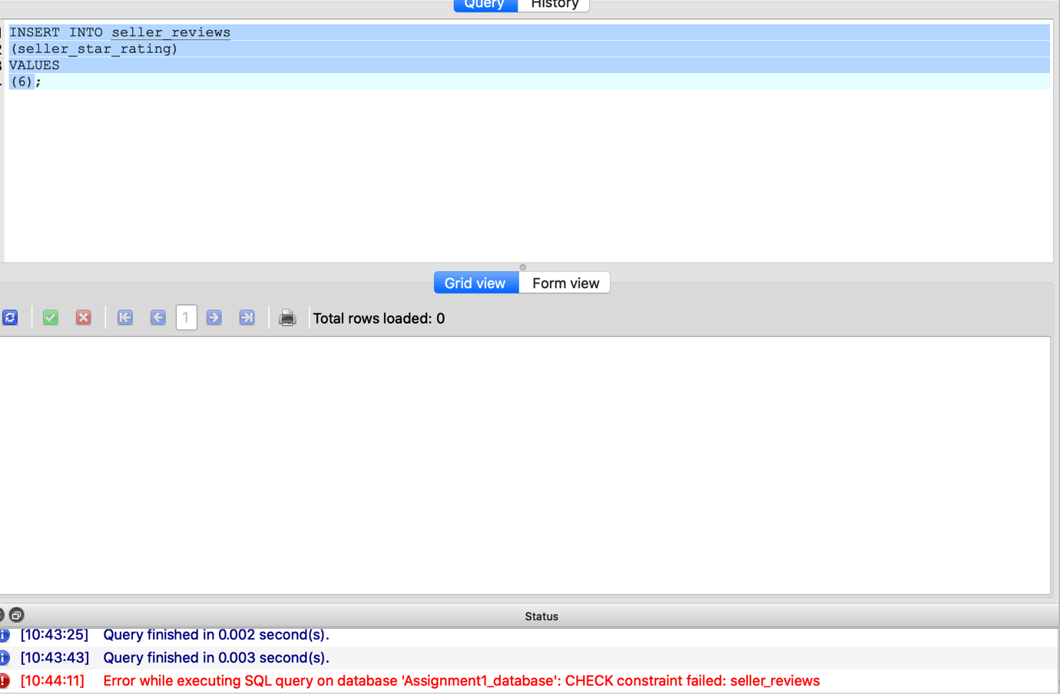



Here you can see that the CHECK constraint in seller_reviews that limits how high the INTEGER in seller_star_rating can be has worked, and has come up with an error when I try to input 6 into that column as it is too high (not in the 1-5 range).

**Code used to test the table**

INSERT INTO seller_reviews

(seller_star_rating)

VALUES

(-1);

**Screenshot of constraint working:**

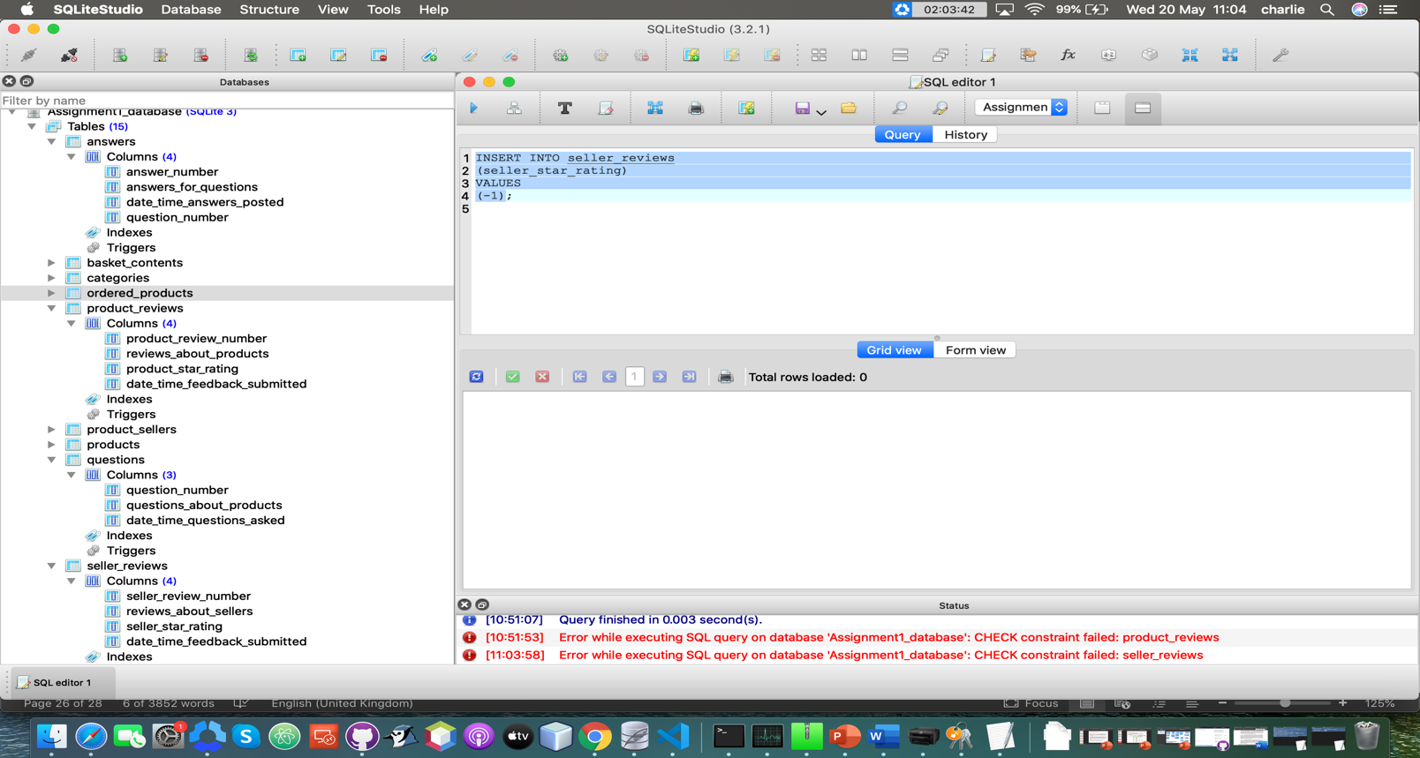

Here you can see that the CHECK constraint in seller_reviews that limits how low the INTEGER in seller_star_rating can be has worked, and has come up with an error when I try to input -1 into that column as it is too low (not in 1 – 5 range).

**Code used to test the table**

INSERT INTO seller_reviews

(seller_review_number)

VALUES

(1)

**Screenshot of constraint working:**

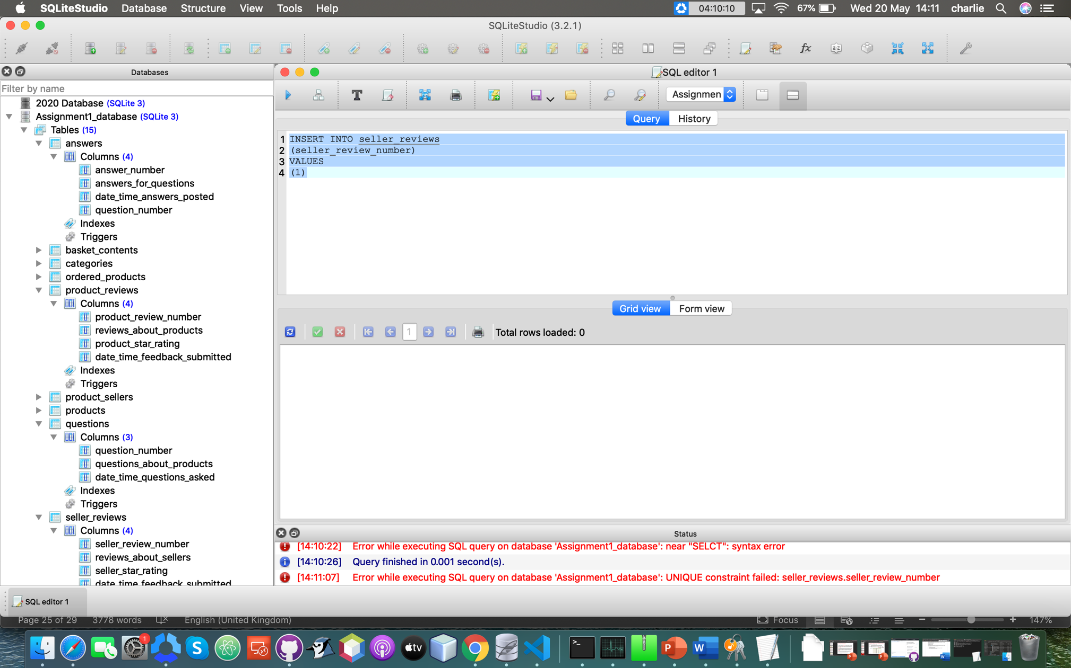

Here you can see that when I try to insert the INTEGER “1” into the seller_review_number column the UNIQUE constraint fails, as I have already got the INTEGER 1 set as a seller_review_number as it autoincrements when I add any data (as show in the “SQL Used to Create the Tables” section), therefore complying with the client requirements.

**Product_reviews table:**

**Code used to test the table**

INSERT INTO product_reviews

(product_star_rating)

VALUES

(8);

**Screenshot of constraint working:**

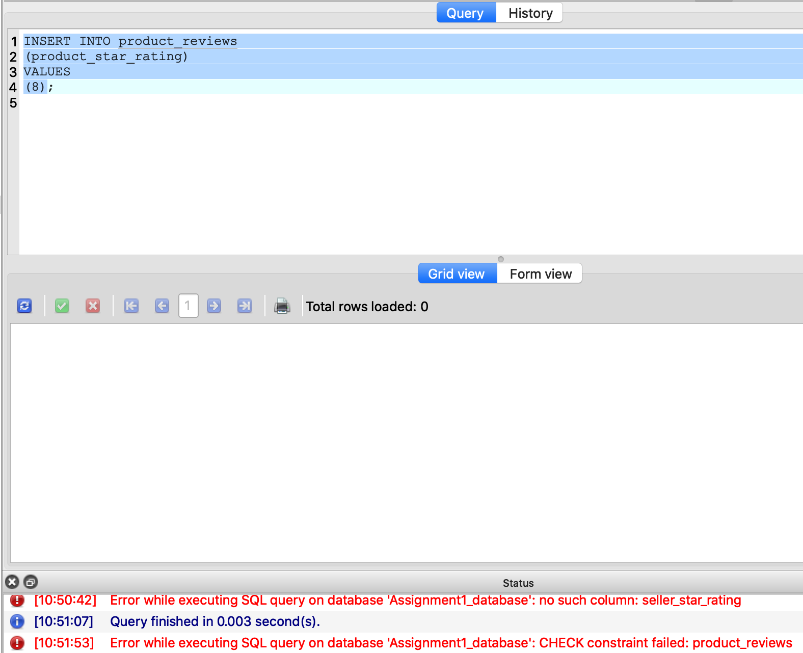

Here you can see that the CHECK constraint in product_reviews that limits how high the INTEGER in product_star_rating can be has worked, and has come up with an error when I try to input 8 into that column as it is too high (not in the 1-5 range).

**Code used to test the table**

INSERT INTO product_reviews

(product_star_rating)

VALUES

(-4);

**Screenshot of constraint working:**

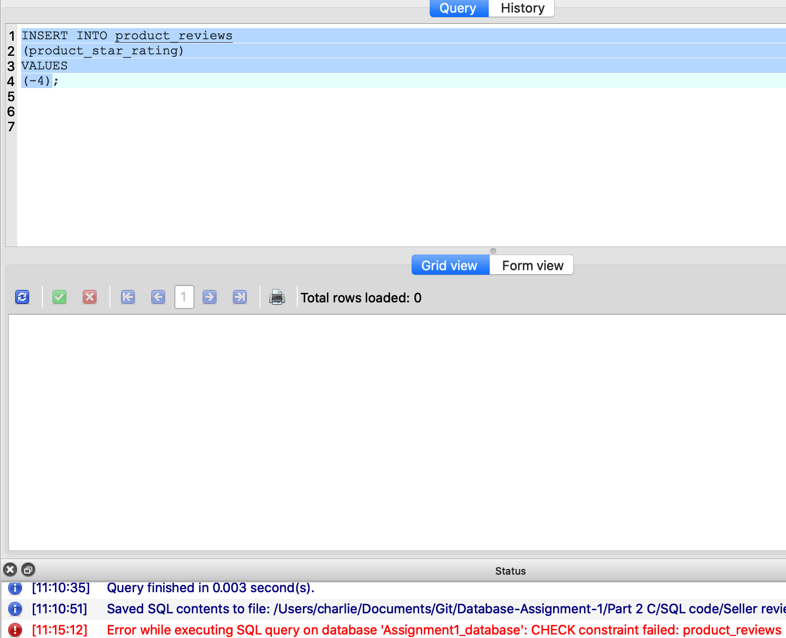

Here you can see that the CHECK constraint in product_reviews that limits how low the INTEGER in product_star_rating can be has worked, and has come up with an error when I try to input -4 into that column as it is too low (not in the 1-5 range).

**Code used to test the table**

INSERT INTO product_reviews

(product_review_number)

VALUES

(4)

**Screenshot of constraint working:**

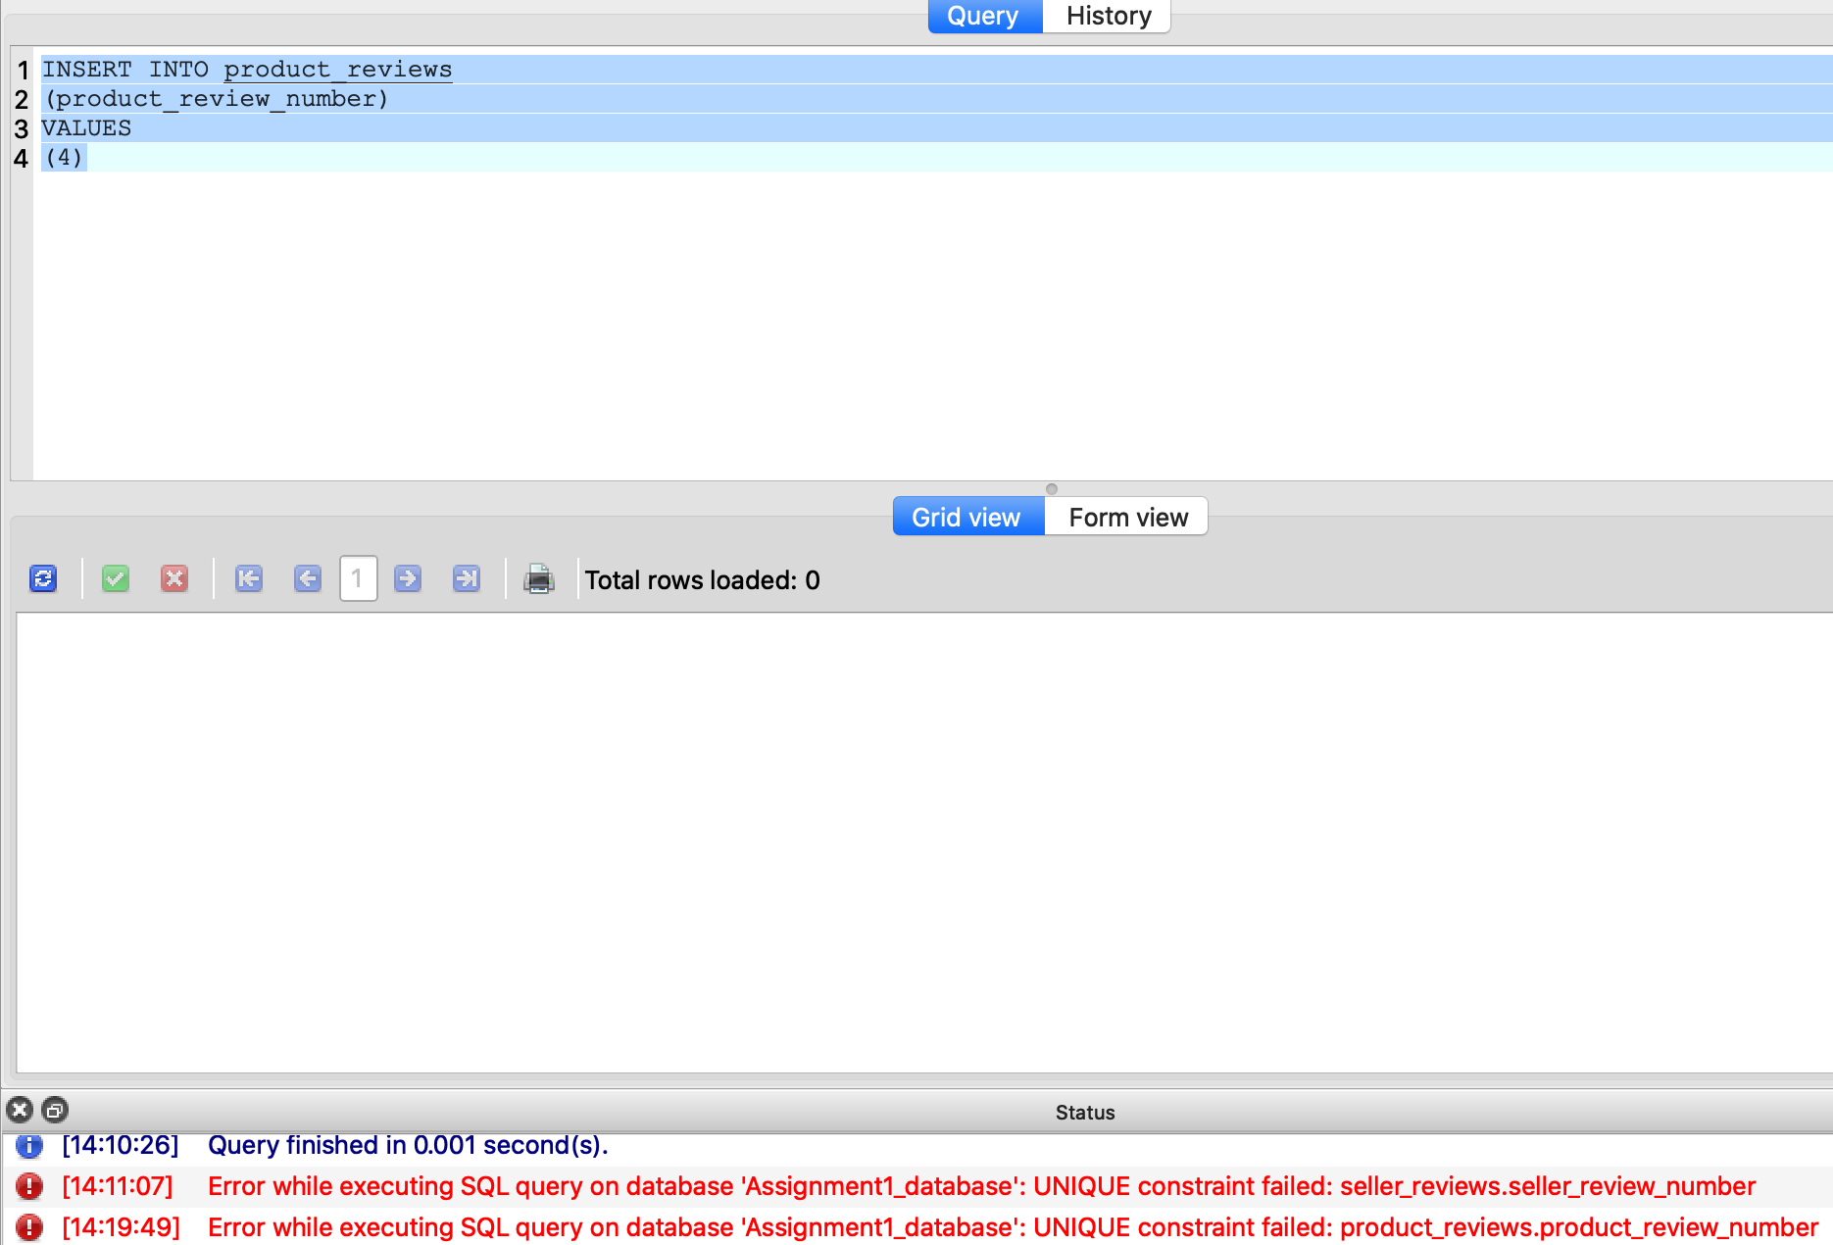

Here you can see that when I try to insert the INTEGER “4” into the product_review_number column the UNIQUE constraint fails as I already have the INTEGER 4 set as a product_review_number as it autoincrements when I add any data (as shown in the “SQL Used to Create the Tables” section), therefore complying with the client requirements.

**Questions table:**

**Code used to test the table**

INSERT INTO questions

(question_number)

VALUES

(1)

**Screenshot of constraint working:**

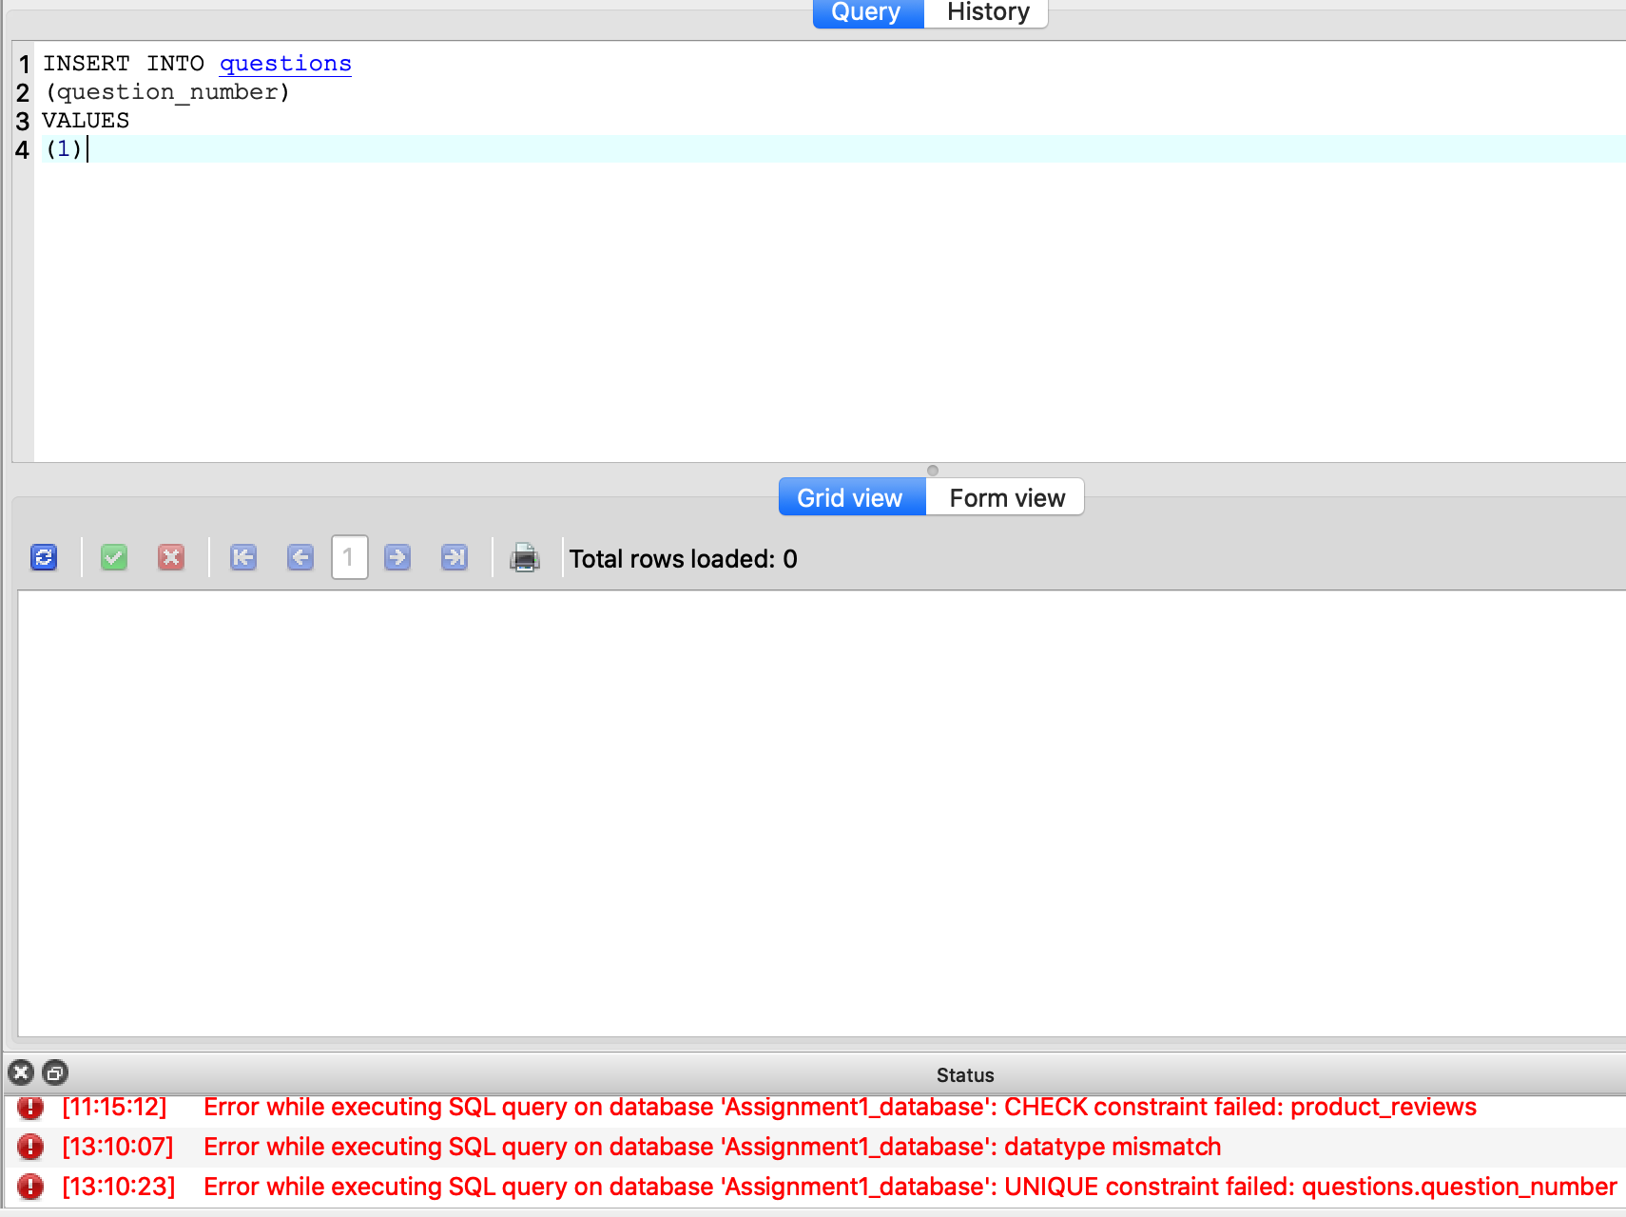

Here you can see that when I try to insert the INTEGER “1” into the question_number column the UNIQUE constraint fails, as I have already got the INTEGER 1 set as a question_number as it autoincrements when I add in any data (as shown in the “SQL Used to Create the Tables” section), meeting the client requirements.

**Answers table:**

**Code used to test the table**

INSERT INTO answers

(answer_number,question_number)

VALUES

(1, 1)

**Screenshot of constraint working:**

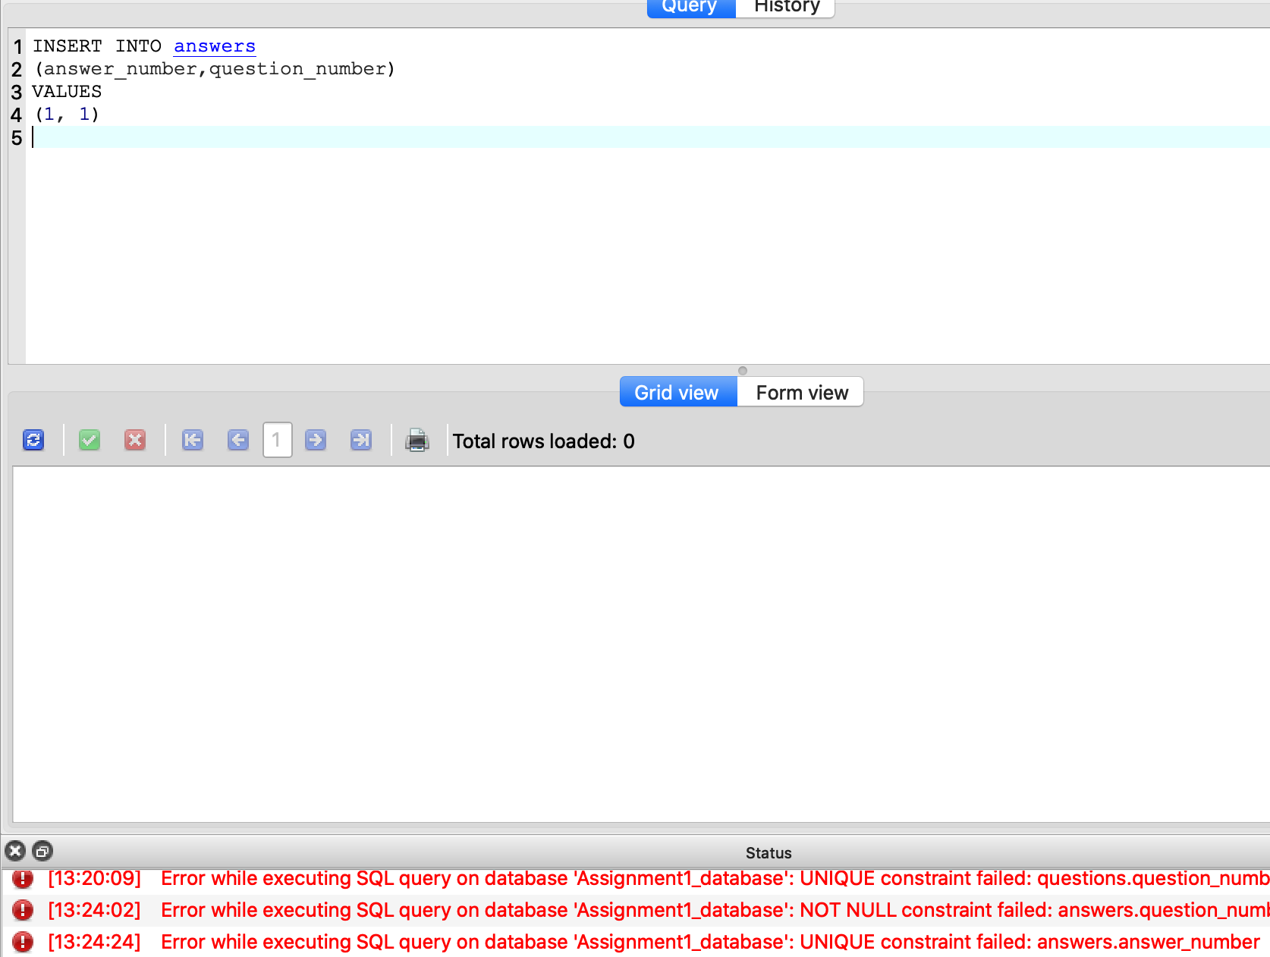

Here you can see that when I try to INSERT the INTEGER “1” into the answer_number column the UNIQUE constraint fails, as I have already got the INTEGER 1 set as an answer_number as it autoincrements when I add in any data (as shown in the “SQL Used to Create the Tables” section), therefore meeting the client requirements.